ARCHERY WORLD CUP
ANTALYA (TUR), 2ND Stage
26 – 31 May 2015



TEAM MANAGERS MEETING
INFORMATION BOOKLET

V 1.0 (DRAFT 18 May 2015)

The Team Managers Meeting will take place at the
Rixos Hotel Downtown, 1st Floor, on May 26 at 16:00hrs

All Team Managers are requested to attend this meeting.
Teams without Team Manager are advised to send one of their
athletes to the meeting.

Please read this document upon receipt
and bring it with you to the Team Managers Meeting.



Dear Team Managers,

On behalf of the Turkish Archery Federation, I would like to wish you a warm welcome to Antalya, 2nd Stage of the Archery World Cup 2015.

I wish all the teams good luck and success.

Mr Husnu KOCAOGLU
Chairman of the Organising Committee

Agenda of the Team Managers meeting

Roll call of all attending nations (ED)

Opening
• Brought to order by the World Archery Event Director (ED), C.MARSH
• Introduction of the panel, by World Archery ED, C.MARSH
• Welcome speech, by World Archery Secretary General, Mr. Tom DIELEN
• Welcome speech, by Organising Committee, Mr. Husnu KOCAOGLU

2) Introduction of Officials (ED)
• Organising Committee members, by the Mr. Husnu KOCAOGLU
• Tournament Judges Commission, by the Chairman of Judges, Mr. Pedro SANZ
• Director of Shooting, by the Chairman of Judges
• Jury of Appeal, by World Archery by Mr. Tom DIELEN

3) Technical Aspects of Competition (ED + Chairman of Judges)
3.1. Number of participants per class
3.2. Competition Programme
3.3. Practice-training
3.4. Equipment Inspection
3.5. Qualification Round & scoring information
3.6. Individual Elimination Round
3.6.1. Recurve
3.6.2. Compound
3.7. Team Elimination Round
3.7.1. Recurve Team
3.7.2. Compound Team
3.8. Individual Finals Round & Team Finals Round
3.9. Appeal Procedure (Form attached)

4) Technical Matters (ED + Chairman of Judges)
4.1. Timing Control system
4.2. Results system
4.3. Rules that apply in this event.
4.3.1. Ranking (World Cup & World Archery Ranking)
4.3.2. Dress regulations
4.3.3. Longines Prize for Precision
4.4. Accreditation Cards rules for 2015

5) Logistical Aspects (OC)
5.1. Transportation: Venue, Airport etc.
5.2. Meals, during practice, Qualification rounds, finals…

6) Protocol and ceremonies (OC)
6.1. Medal Ceremonies, Mixed Zones and Press Conferences

7) Medical Related issues (Medical representative)

8) Clean Sport (Medical representative)
8.1. Doping control
8.2. Alcohol test

9) Other matters of Importance (World Archery ED)

10) Questions from Team Managers

11) Closure (ED)

Important entry deadline dates for future events:

Date: | Event: | Entry Deadline Type
26 May | Para Archery World Championships | Preliminary Entry
3 June | 3D World Championships | Preliminary Entry
9 June | World Cup Stage 4 – Medellin | Preliminary Entry
5 July | World Championships Copenhagen | FINAL Entry
21 July | World Cup Stage 3 – Wroclaw | FINAL Entry
2 August | Para Archery World Championships | FINAL Entry
10 August | 3D World Championships | FINAL Entry
18 August | World Cup Stage 4 – Medellin | FINAL Entry

Note:
Training Camp available for teams in Legnica, Poland after the World Championships and before the 3rd stage of the World Cup in Wroclaw.

IMPORTANT TELEPHONE NUMBERS

Competition Management
Mr. Husnu KOCAOGLU +90 532 276 98 08

Technical Requirements & Field Mgr.
Mr. Hakan CAKIROGLU +90 532 422 51 00

Hotel and Accommodation
Mr. Sirer AYDIN +90 533 515 25 33

Transport Manager
Mr. Behiç LOKLUOGLU +90 533 384 76 01

Medical Care
Prof. Dr. Rustu GUNER +90 532 272 01 50

Press Operations
Miss. Esen DONMEZ +90 506 271 71 58

World Archery Federation (WA)
Mr. Chris MARSH (WA ED) +41 79 739 89 95

OFFICALS
Tournament Judge Commission Chairman:

Mr. Pedro SANZ

Director of Shooting:
GOZACAN Tahsin CINAR

World Archery Judges:

- Robert ERICA
- Celine GRAVEL
- Rupesh KAR
- Kathy LIPSCOMB
- Drasko MIHINJAC

National Judges

- ASLAN Nevin
- ASLIM İpek
- CAKIR Merve
- GOZACAN Tahsin CINAR(DoS)
- KELESTEMUR Ufuk
- OZDEMIR Serdar
- SENTURK Ibrahim(Assistant of DoS)
- TASTAN Ilyas
- UNSAL Aslıhan Muazzez
- URAZ Derya
- YAMAK Ferhat
- YUCEER Soner

Jury of Appeal:
To be announced on the day of the Team Managers Meeting

WA Results & Technology Team:
Mr. Matteo PISANI

World Archery Communication:
Mr. Chris WELLS

World Archery Clean Sport Supervisor
Mr. Rustu GUNER

Points to clarify
3) Technical Aspects of the competition (WA Event Director + Competition Manager + Chairman of Judges)

3.1. Number of Participants per category (Number of Nations/Region: 54)

Recurve Men Individual: 161 (1/48) Teams: 37 (1/8)
Recurve Women Individual: 130 (1/48) Teams: 31 (1/8)
Compound Men Individual: 84 (1/48) Teams: 19 (1/8)
Compound Women Individual: 64 (1/48) Teams: 14 (1/8)

MIXED Teams COMPOUND 24 (1/8)
MIXED Teams RECURVE 42 (1/8)

(Updated 18 May 2015)
3.2. Competition Programme
The latest competition programme will be provided 1 week prior to official practice on the World Archery website. Any official competition schedule will have indicated the version number and the date/hour it was printed. Latest version of the Competition Schedule is V 1.0 (updated 18 May 2015, 12:00 h)

3.3 Practice
- Available at the Antalya Konaalti Municipality Football Field, from 24 and the morning of May 29. Transportation provided at no extra cost and will be displayed in the hotel lobbies.
- Afternoon of May 29th and the morning of May 30, practice will be at the Qualification/Elimination range and will then close from 12:00hrs
- General times for the practice range is, 09:00hrs – 12:00hrs and 15:00hrs – 18:00hrs.
- Teams wishing to practice before 24 May, are to arrange directly with the Local Organising Committee and cover the cost of transportation.
- All transport schedules for the practice range, will be posted in all hotel lobbies.
- Practice at the finals venue will be available for those athletes competing on their respective day i.e. Compound on May 30 and Recurve on May 31, open from 10:00hrs – 14:00hrs.

Official Practice
- 09:00hrs – 12:00hrs for Recurve Men and Compound Women shooting AB-CD format.
- 13:30hrs – 16:30hrs for Compound Men and Recurve Women shooting AB-CD format.

Qualification Round Practice
- 3 ends of 4 minutes practice on the Field of Play for the qualification competition to immediately follow once the field is ready.
- Non competing athletes can use the practice field, a short bus ride from the qualification competition venue.

3.4. Equipment Inspection:
- 26 May, during official practice.
- Located in the athlete sheltered area behind targets 1, 2 and 3.
- Teams will be announced in (English) alphabetical order by the DOS.
- All teams are to wear their team uniform and bring their accreditation.
- Spare equipment must also be brought for inspection.
- Team Managers are to check the details of their athletes such as, name, date of birth are correct.
- Inform the Judge if details are not correct and the Judge will inform WA Results Team.
- Instructions to use the new tablet scoring system will be carried out if requested.

Athlete (back) Numbers:
- Athlete numbers will be issued on the day of the qualification round during practice.
- Athlete numbers must be worn on the quiver or thigh, facing the waiting line while shooting.

The Environment:
- Team Managers please instruct your team members to use the litter bins located on the competition, practice ranges and common areas.

Water:
- In an effort to aid the environment, water will be distributed using the familiar WA bottle deposit system.
- Water bottles will be distributed behind the athletes’ rest area located to the right of the qualification and elimination field.

Non Smoking
- This is a non-smoking event.
- Smoking is forbidden inside public buildings and all competition and training areas and within the security parameter of the venue.
- There are designated smoking areas outside the venue.

3.5. Qualification Round
RECURVE - 27 May - Morning Recurve Men
Afternoon Recurve Women
4 athletes per target, Shooting AB-CD format
70m Round (72 arrows)

COMPOUND - 27 May – Morning Compound Women
Afternoon Compound Men
4 athletes per target, Shooting AB-CD format
50m Round (72 arrows)

*Note: There will be a 10mins comfort break between the 6th and 7th end.

3.6. Individual Elimination Round
- 28 May for both Recurve and Compound disciplines.
- Target faces will NOT be changed after practice arrows. Please instruct your athletes to mark all arrow holes during practice.
- Matches will start as soon as the field is ready.
- Matches at the start of each session will begin on time. Proceeding matches will follow up on the immediate completion of the prior match. Athletes should be alert and prepared for their matches to start slightly earlier than scheduled.
- Byes are permitted. In case of a bye, athletes may be allowed to shoot on their own target, provided the competition schedule allows. If the competition schedule allows, no score will be recorded or displayed and athletes shooting their bye must respect the DOS timing and signals of the competition. Recurve athletes are permitted to shoot 3 ends of three arrows of practice and compound athletes are permitted to shoot 5 ends of three arrows practice for their bye.
- Individual elimination rounds will start at the 1/48 elimination stage (104 athletes, in each category or less, depending on entries).
- The top 8 individual ranked athletes from the qualification round will progress directly to the 1/16 finals.
- Athletes ranked 9th to 104 position will shoot the 1/48 and 1/24 eliminations.
- There will be no alternate shooting during the preliminary elimination.
3.6.1 Recurve Elimination
- The sets system, will be used for all individual, team and mixed team matches. Individual matches will consist of the best of 5 sets, (3 arrows per set) and the winner is the athlete to reach a minimum of 6 set points first. Team and mixed team matches will consist of the best of 4 sets (6 arrows per team and 4 arrows per mixed team). The team that reaches a minimum of 5 set points first will win the match. All matches, up to and including the semi-finals, will be shot simultaneously on the qualification range for the individual, team and mixed team events.

Book 1, 4.5.1.4 (Recurve)
• The Elimination Round, in which the top 104 athletes (mandatory for World Archery Championships) are seeded according to their positions in the Qualification Round (see match play chart Appendix 10 and Book 2, Appendix 1). Athletes shoot a series of matches in groups, each match consisting of the best of 5 sets of 3 arrows;

3.6.2 Compound Elimination
- Matches for all compound events will use the cumulative scoring, consisting of 5 ends of 3 arrows. All matches, up to and including the semi-finals, will be shot simultaneously on the qualification range for the individual, team and mixed team events.

Book 1, 4.5.1.5 (Compound)
• The Elimination Round in which the top 104 athletes (mandatory for World Archery Championships) are seeded according to their positions in the 50m Qualification Round (see match play chart Appendix 10 and Book 2, Appendix 1). Athletes shoot a series of matches in groups, each match consisting of 5 ends of 3 arrows;

- Shoot offs in individual elimination for both recurve and compound will be decided by a one arrow shoot off “closest to the centre” (40 seconds). Time to shoot an arrow for shoot offs during alternating shooting is 20 seconds. Team shoot offs up to and including the semi-finals, will be shot simultaneously, and then alternatively, arrow by arrow, in medal matches.

3.7. Team and Mixed Teams Elimination Round
- 27 May - MIXED TEAM ELIMINATION
- 29 May - TEAM ELIMINATION
- Start at the 1/8th phase
- No alternating shooting
- Byes permitted, teams will be allowed to shoot on their allocated target, but no score will be recorded or displayed.
3.7.1. Recurve Team
- 29 May
- Starting at the 1/8th phase until the semifinals
- Up to 4 sets of 6 arrows, 2 arrows per athlete (70m, sets system)

3.7.2. Compound Team
- 29 May
- Starting at the 1/8th phase until the semifinals
- 4 ends of 6 arrows, 2 arrows per athlete (50 m, cumulative scoring)

3.8. Individual Medal Matches
- 30 May - COMPOUND
- 31 May - RECURVE
- Finals to be staged at Beach Park, Downtown Antalya.
- Venue for finals will have a “Practice field”.
- Practice field:
- Will have 4 targets.
- The area will have water, tents, chairs and tables.
- Practice Field will be open 1 hour before the start of competition.
- Athletes are not permitted to use scopes on the finals FOP.
- Coaches will be fitted with a wired individual microphone to record their comments for TV purposes. No sound will go out to the venue. Microphones will be activated immediately when entering the FoP for the match and removed when the match is completed. Coaches’ comments will be recorded for use in the TV highlights and on matches placed on www.archery.tv platform.

3.9. Appeal Procedure (Form attached)
- An Appeal form is attached to this document (see attached after this chapter, Appendix 1).
- In case of an Intent to Appeal or an actual Appeal, the times indicated on the Appeal form must be considered.
- Appeal forms should be given to the Chairman of the Tournament Judge Commission or to their deputy.
- A fee of US$50- (Euro 45.-) must be paid to the Chairman of the Tournament Judge Commission, for the Appeal to be valid.
- If the Appeal is upheld by the Jury of Appeal, the fee will be returned. In the case of the Appeal being rejected, the fee will not be returned.

4. Technical Matters (ED + Chairman of Judges)
4.1 Timing Control System
- LONGINES Timing equipment will be used for timing and scoreboards.
4.2. Results System
- Qualification Round - scoring will be done by athletes. One athlete records, on the official paper based score sheet, the scores of all other athletes on that target. At the same time, another athlete, on that same target, will enter all the scores of the athletes on that target into the scoring tablet. The other athletes should verify that all scores are written and entered correctly.
- Scorecards MUST have all the totals fully completed, with the 10’s+X’s and X count. Any scorecards not completed correctly with this information will be counted and scored as 0.
- Elimination Round – scoring will be done by athletes. One athlete/team records the arrow values of both athletes/teams on the papers score sheet. While at the same time, the other athlete/team inputs the arrow values in the scoring tablet. Both athletes/teams should verify that all scores are written and entered correctly before returning back to the shooting line.
- At the end of the match, the scorecard must be fully completed and signed by the athletes involved in the match.
- Scoring tablets will be used during the Qualification and Elimination Rounds, but not in the Finals. Mr Matteo PISANI (WA Results & Technology Team) is responsible for the results of the event.

4.3 Rules that apply in this event

4.3.1. The Rankings
- At the end of the event, the World Cup Rankings (www.archeryworldcup.org) and the World Rankings (www.worldarchery.org) will be updated.

4.3.2. Dress Regulations
- Athletes, officials and staff should wear the appropriate clothing having the correct appearance when on the field during competition. Camouflage clothing or accessories are not permitted.
- Athletes, team officials and technicians should wear their national team uniforms and sports shoes having the same appearance as per the division, following WA rules.
- We would like to remind all teams that athlete names and country names or codes are mandatory on the back of their national team uniform shirts for athletes participating in WA major events.

4.3.3. Longines “Prize for Precision”
- The Longines “Prize for Precision” for archery was launched in 2010. The two most precise athletes in a World Cup season will win the trophy, a Longines watch and a 5.000 Swiss Francs prize.
- In odd years, compound athletes shoot for the Longines Precision prize. In even years, recurve athletes compete for the prize. 2015, compound male and female athletes are eligible to win the prize this year.
- Athletes shooting the most 10s during the World Cup individual qualifications and elimination matches as of the 1/16 eliminations of the World Cup stage, can win.
- The race for the LONGINES Precision Prize will continue until the very last match at the World Cup Final in Mexico City!
- During a AWCS, one Longines watch will be awarded to the athlete who shoots the most 10s during the competition (during the individual qualifications and the matches from the 1/16 final phase) in a chosen category, per event, as follows:

      - Shanghai: Recurve Women KANG Chae Young (KOR)
      - Antalya: Compound Women
      - Wroclaw: Recurve Men
      - Medellin: Compound Men

4.4 Accreditation Cards Rules for 2015 and following (1 card per participant/season)
- In 2011, World Archery launched their accreditation card system.
- Athletes and officials participating in World Cups will be issued with only ONE accreditation (card, plastic cover and lanyard) for the entire season.
- Accredited persons are required to keep their newly issued accreditation for all the events in 2015 and 2016.
- All persons (athletes and staff) are required to update their accreditation and profile photos at their first event of 2015.
- All accreditation cards need validating for each event when registering with the Organising Committee at the tournament.
- Athletes or officials that forget or lose their accreditation will be issued a new accreditation and will need to pay EUR 25 (USD 30) per card.
- However, if there is a valid reason for not having the original accreditation, this should be made known to WA by the Team Manager or official.

5) Logistical Aspects (OC)
5.1. Transportation
- Daily transport information and schedules will be placed at the competition field and at all the official event hotels.

5.2. Meals during the event
- Meals will be served at the hotel restaurants according to the schedule below:

1. Rixos Hotel Downtown Antalya
Breakfast/Lunch/Dinner: Restaurant, Ground Floor
2. Harrington Park Hotel Antalya
Breakfast/Lunch /Dinner: Restaurant, Ground Floor

*Catering Times:
Breakfast 06:30 - 10:30
Lunch 12:30 - 14:30
Dinner 19:00 - 21:30

* Catering times may be adjusted according to the daily schedule. Teams will be informed in advance.

5.3. Access Control
Athletes who are not in competition will not be allowed on the competition field. Stickers of different colors will be placed on each athlete’s accreditation cards showing which category they are competing in.

Athletes who are not in competition may watch the event from behind the athlete shelter. A pathway will be laid out for archers and officials to walk to the stands once they get off the buses at the venue’s drop-off point.

Athletes who are eliminated are required to collect their equipment and leave the competition area as soon as possible to allow more room for those athletes still competing.

6. Protocol and ceremonies (OC)
6.1. Medal Ceremonies
- To begin immediately after the end of the last match.
- All athletes involved in the ceremonies are requested to go to the gathering point. Location will be confirmed during the event.
- All medal winners are requested to be present at the finals venue gathering point of the Award Ceremony, 15 min before the ceremonies are due to start.
- Medal ceremonies will be conducted immediately after the conclusion of each session during the days of the finals (please check the competition schedule).

Mixed Zone and Press Conferences:
- Interviews will take place at the Mixed Zone and athletes will be requested to pass through the mixed zone to speak with the media.
7. Medical Related issues (Medical representative)
- First Aid services will be available during training days from 24–29 May. Ambulance and First Aid services will be available from 30 - 31 May at the Beach Park, Downtown Antalya (Finals Venue).
- A doctor and a nurse are available on site for any emergency.
- In cases of emergency in official hotels, please inform the contact person in each hotel.
- The closest hospital for emergencies is Antalya Education and Researching Hospital TEL: +90 242 249 44 00. Varlik Mah. Kazimkarabekir Cad. Muratpasa/ANTALYA.

8. Clean Sport
8.1 Anti-Doping control
- Anti-Doping control will follow World Archery rules (World Cup and World Ranking events).
- Athletes should bring their passports and/or accreditation cards to the anti-doping control station if selected for a test.

8.2. Alcohol test
- Athletes should also be available for random alcohol testing during the competition, following World Archery rules.

9. Other matters of importance (WA ED)
- Accreditation cards must be worn at all times in the practice and competition areas.
- Only athletes scheduled to compete at certain stages of the event are permitted on the main Field of Play, together with one coach/official.
- In order to improve the standard of our events, athletes and team members are kindly requested to complete the online event evaluation questionnaires when they receive the email from World Archery.

Internet access:
- Internet access will be free of charge in the rooms and lobby of official hotels.
- All other hotel expenses including laundry and minibar, etc will be covered by the participants themselves.
- Internet access will be available at the qualification venue for live results.

10. Questions from Team Managers

11. Closure (EM)


Mixed Team
Member Nomination Form

National Team: …....................................................

RECURVE Mixed Team:
1. …...................................................................
2. …...................................................................

COMPOUND Mixed Team:
1. …..................................................................
2. …..................................................................

Name and Signature of Team Official:

………………………………………………………………………………………………………..

Results of the 2 highest scoring male and female members of the team, will automatically be used for the mixed team event. If Team Managers wish to use other athletes in the team, pleased use this form to name the athletes that will be competing in the mixed team event.

Forms to be given to WA Event Director or Chairman of the Judges Commission before 17:00 on 27 May.
Team Member Nomination Form

National Team: …....................................................

Recurve Women:
1. …................................................................................
2. …................................................................................
3. …................................................................................
athlete NOT in the team: …...........................................

Recurve Men:
1. …................................................................................
2. …................................................................................
3. …................................................................................
athlete NOT in the team: …...........................................

Compound Women:
1. …................................................................................
2. …................................................................................
3. …................................................................................
athlete NOT in the team: …...........................................

Compound Men:
1. …................................................................................
2. …................................................................................
3. …................................................................................
athlete NOT in the team: …...........................................

Name and Signature of Team Official:

…....................................................................................................

Results of the 3 highest scoring members of the team, per discipline and gender will automatically be used for the team events. If Team Managers wish to use other athletes in the team, pleased use this form to name the athletes that will be competing in the team event. Forms to be given to WA Event Director or Chairman of the Judges Commission before 8:15 on 29 May.

THE ARCHERY VENUES
Venue for Qualification & Eliminations
Antalya Archery Club Field,
100.Yıl Okculuk Tesisleri Meltem Mahallesi Muratpasa, Antalya, Turkey

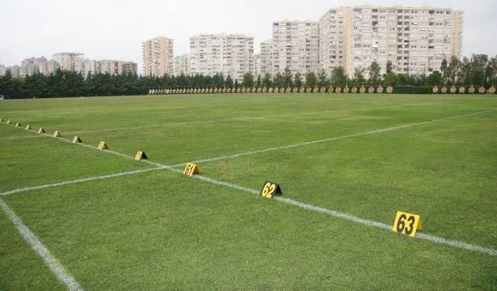

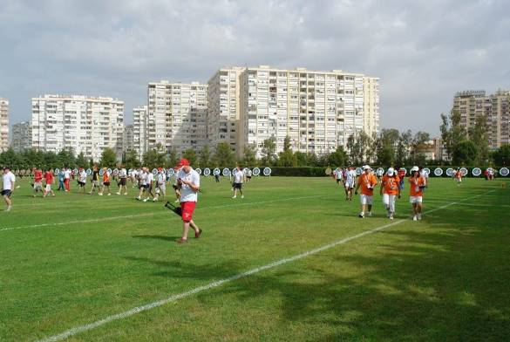

Practice Field

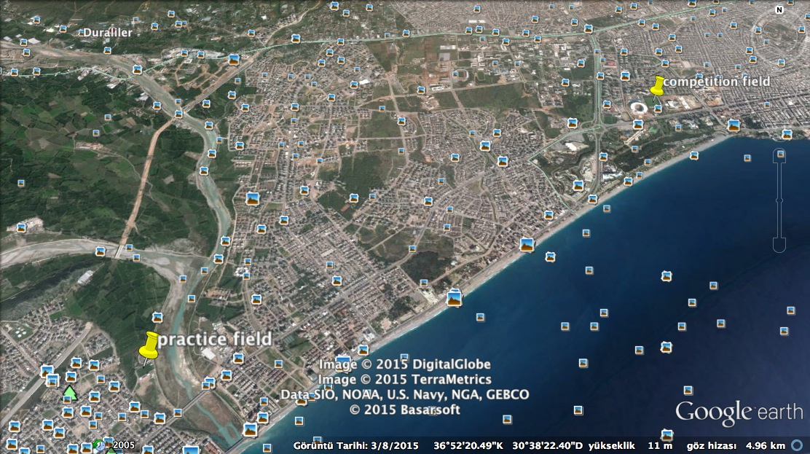

NOTE:

Practice field is at the Antalya Konaalti Municipality Football Field and will be available:
- 24.05.2015 09:00hrs – 12:00hrs & 15:00hrs – 18:00hrs
- 25.05.2015 09:00hrs – 12:00hrs & 15:00hrs – 18:00hrs
- 26.05.2015 09:00hrs – 12:00hrs & 15:00hrs – 18:00hrs
- 27.05.2015 09:00hrs – 12:00hrs & 15:00hrs – 18:00hrs
- 28.05.2015 09:00hrs – 12:00hrs & 15:00hrs – 18:00hrs
- 29.05.2015 09:00hrs – 12:00hrs

Antalya Archery Club Team Field will be available for practice:
- 29.05.2015 14:00hrs – 18:00hrs
- 30.05.2015 09:00hrs – 12:00hrs

Venue for FINALS
Antalya Beach



