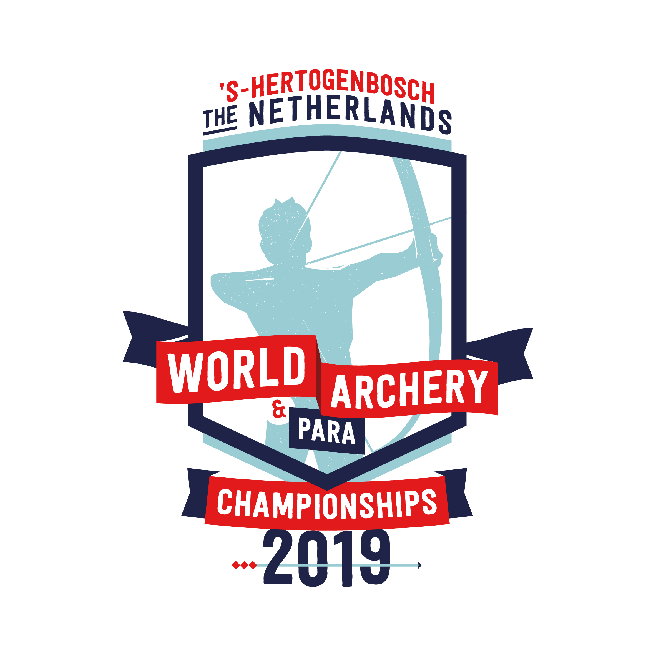

**WORLD ARCHERY CONGRESS**

**INVITATION PACKAGE**



**WORLD ARCHERY CONGRESS**

**INVITATION & INFORMATION PACKAGE**

‘s-Hertogenbosch – The Netherlands

Dear Member Associations, Dear Congress Delegates:

This document has been created for those who will participate in the World Archery Congress. Congress delegates will need to register their participation for congress and book their accommodation for congress using WAREOS.

**SCHEDULE of the CONGRESS**

(As of 19 January 2018)

Friday, 31 May 2019 as of 9.00 am World Archery Executive Board

meeting

Saturday, 1 June 2019 8.00 am to 9.00 am Registration

9.00 am Official Opening of the Congress

6.00 pm End of work session (day 1)

*Followed by* Dinner at Congress venue

Sunday, 2 June 2019

8.00 am to 9.00 am Registration

9.00 am Start of the work session (day 2)

5.00 pm Official Closing of the Congress

Date and time to be Meeting of the newly elected World Archery Executive

confirmed Board

Lunch will be arranged for delegates and other congress participants on 1 - 2 June at the congress venue as well as dinner directly after the work sessions 1 June.

**Congress location:**

Provinciehuis Noord-Brabant (regional government building)

Brabantlaan 1, 's-Hertogenbosch, The Netherlands

**CONGRESS REGISTRATION**

Congress registration, accommodation reservations, transport needs, flight arrival/departure information and visa invitation letter requests are to be completed fully using WAREOS.

To register please follow this link: https://extranet.worldarchery.org/

Then, using your current WAREOS account login, you will see a form (as shown

below) to fill in with all your information.



**NOTE:**

For those congress delegates that will also be attending the World Archery Para Championship or World Championship as a coach or team manager etc, will need to register and reserve their accommodation separately for those events in WAREOS.

**Official congress hotel**

|  |  |  |
| --- | --- | --- |
| **Congress Hotel** | **Single Room** | **Double Room** |
| De Ruwenberg Hotel | 230 EUR | 137,50 EUR |

De Ruwenberg Hotel (official hotel of World Archery Congress)

The hotel room rates are **per person, per night** and including breakfast and free WIFI. Lunch and coffee/tea breaks during the congress on 1 - 2 June are included. Dinner at the congress location on 1 June is included. Additional purchases in the hotel bar, café and minibar is at own expense.

Check-in at the hotel is at 2:00 pm, rooms will not be available until this time.

Check-out time is at 10:00 am, please make sure to do the check-out at the front desk before this hour, otherwise an extra night will be charged.

The check-in date for Congress is 31 May and the check-out date 2 or 3 June 2019, if you need early arrivals or late departures, please let us know by email [manouk@theorganizingconnection.nl](mailto:manouk@theorganizingconnection.nl) so we can confirm if there is availability.

Transportation will be provided between De Ruwenberg Hotel and the congress location Provinciehuis Noord-Brabant. Transport timetables will be confirmed.

In the event that the number of reservations exceed the hotel’s availability, the LOC will provide alternative accommodation, for which the same rates and conditions will apply.

**NOTE:**

Transportation to the congress is only offered from the Congress Hotel – **De Ruwenberg**. Those congress delegates not staying at the De Ruwenberg Hotel will need to make their own transport arrangements.

**De Ruwenberg Hotel**

Please check the official event website for detailed hotel information:

<http://www.archery2019.com>

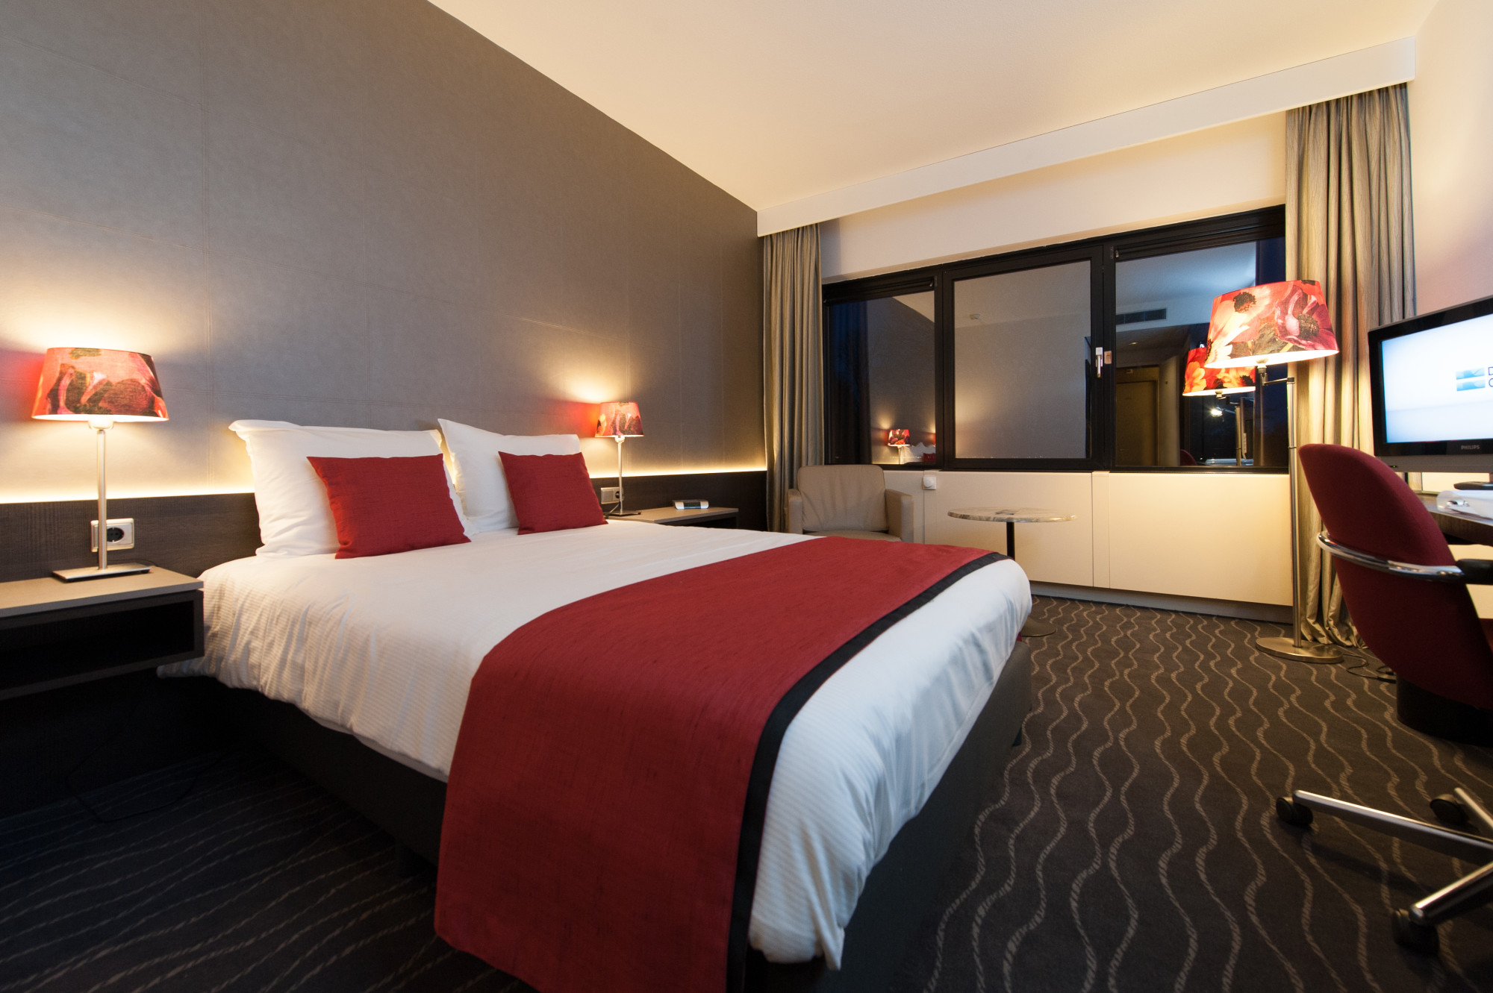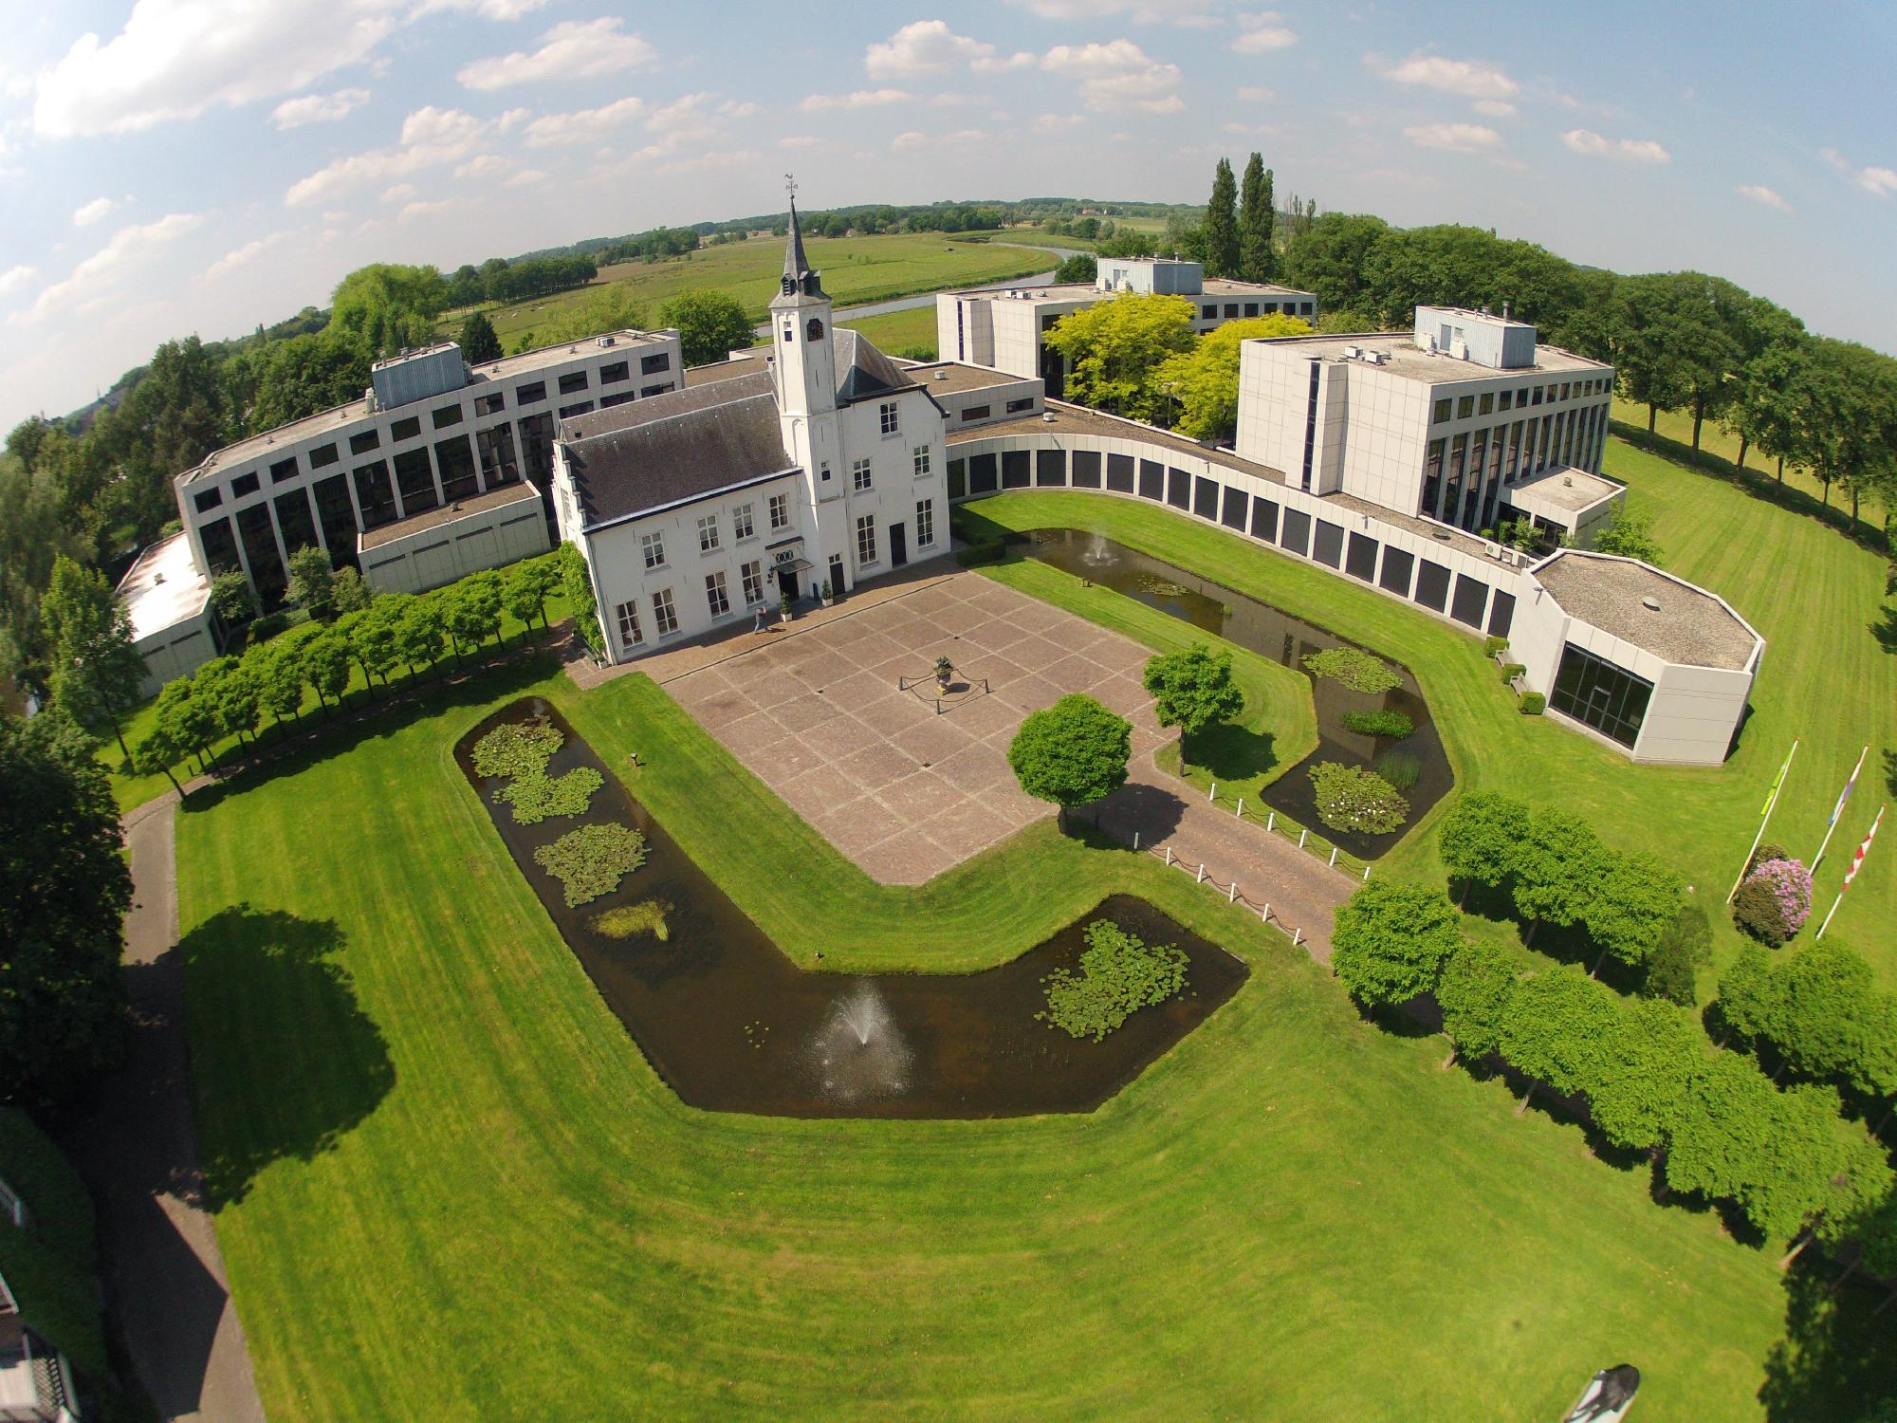

**Payment conditions Hotel**

To confirm your hotel reservations, a 60% deposit of the total amount, is to be paid by a bank transfer to the Organising Committee before **12 April 2019.** Reservations received after this date will be considered according to availability.

BANK INFORMATION for ACCOMMODATION and TRANSPORTATION:

BANK: RABOBANK Oss Bernheze

ADDRESS: Postbus 20, 5384 ZG Heesch

BANK ACCOUNT HOLDER NAME: The Event Connection B.V.

ACCOUNT NO: NL83 RABO 0125 5232 54

BIC/SWIFT CODE: RABONL2U

**NOTE**: All payments shall be made in EUR by BANK TRANSFER.

Bank transfer fees are the responsibility of the SENDER.

CREDIT CARDS and TRAVEL CHECKS cannot be accepted.

**Transport**

Traffic between Amsterdam Schiphol airport and s-Hertogenbosch is frequently busy. Therefore, the most efficient and effective way to travel is by train.

**Public transport**

Train from Amsterdam Schiphol airport to the Central station of ‘s-Hertogenbosch. One-way ticket will cost around € 18 (2nd class ticket), around € 28 (1st class ticket).

Volunteers from the organising committee will be at Schiphol airport to meet, greet and provide assistance in purchasing a train ticket and guide you to the correct platform for the train to ‘s-Hertogenbosch.

When you arrive at ‘s-Hertogenbosch central train station, you will be met again by volunteers from the organising committee. Who will assist you to with transport to the congress hotel.

Event transport on Friday May 31 from ‘s-Hertogenbosch central train station to the congress hotel will be arranged by the organiser free of charge. Should you arrive earlier than Friday May 31, there are taxi’s available at ‘s-Hertogenbosch central station to travel from the railway station to your hotel. Payment can be made by cash or card. For more information about traveling by train you can check the website [www.ns.nl/en](http://www.ns.nl/en).

Airport transfer

Alternatively, you can reserve a dedicated taxi pick up and drop off (round trip) service from and to the airport with our travel partner, Arriva.

**Amsterdam Schiphol Airport – ’s-Hertogenbosch\***

|  |  |  |
| --- | --- | --- |
|  | One-way | Retour |
| Taxi (max 3 persons) | € 345,- | € 690,- |
| 9 persons van | € 406,- | € 811,- |

**Eindhoven Airport – ’s-Hertogenbosch\***

|  |  |  |
| --- | --- | --- |
|  | One-way | Retour |
| Taxi (max 3 persons) | € 194,- | € 388,- |
| 9 persons van | € 357,- | € 714,- |

*\* prices are per taxi/van*

Contacts:

General information on the congress:

Name: Jacqueline Hoeks

E-mail: [jacqueline@theorganizingconnection.nl](mailto:jacqueline@theorganizingconnection.nl)

Phone: +31 412 405280

Accommodation, transport and visa:

Name: Manouk van den Elzen

E-mail: [manouk@theorganizingconnection.nl](mailto:manouk@theorganizingconnection.nl)

Phone: +31 412 405280

WAREOS registration system:

Name: JK LEE

E-mail: [jklee@archery.org](mailto:jklee@archery.org)

**Deadline for congress registrations:**

**10 May 2019**