

https://www.ul.ie/marcomms/sites/default/files/user_media/gallery/aerial/DJI_0162_1.JPG

**June 10th – 13th 2021**

**Ireland’s Sports Campus**

**University of Limerick**

*Athletes Invitation*

Emerald Isle Cup 2021

TO ALL World Archery Member Associations

Dear President,

As Chair of the Local Organizing Committee, I would like to invite you all to be part of the inaugural Emerald Isle Cup in 2021 at the University of Limerick – Ireland’s Sports Campus.

Limerick, famed as Ireland’s Sporting Capital, is an ancient city on the banks of the majestic River Shannon. Limerick offers energy, excitement, grit and limitless possibilities from its Atlantic location, combined with the timeless, creative and hospitable character of Europe.

​

We are proud to launch an annual world-ranking event here in Limerick, the future host city of the 2023 World Archery Youth Championship. From its beautiful Georgian architecture and grand museums to its sport-obsessed locals, this city will win you over with its unique charm.

​

Limerick has been creating a name for itself as a key destination for business and sports tourism. Offering visitors the best of both worlds: modern hotels and venues in an energizing city with the spectacular backdrop of Irelands Wild Atlantic Way, a vision of Irelands picture postcard appeal.

Limerick is just twenty minutes from Shannon airport with connectivity to UK, Europe, USA and Canada daily.

We welcome you to this amazing city and hope to be given the opportunity to deliver a world-class sporting memory for everyone involved.

Sincerely yours,

Adam Taylor

LOC Chairman

Important Dates:

Please find enclosed information regarding the details of this event and how to complete registration. To register participation, please complete all the necessary sections in WAREOS within the deadlines listed below:

Summary of deadlines:

* Start date for online registration WAREOS 1st August 2020
* Preliminary Entries 1st March 2021
* Final Entries 1st May 2021
* Extra penalty starting date 1st May 2021
* Hotel Reservation 1st May 2021
* Transportation 1st  May 2021
* Visa Support 19th March 2021
* Final Hotel Reservation & Payment 9th May 2021
* Full refund cancellation deadline 9th May 2021

Looking forward to welcoming you in Limerick City Ireland.

PRELIMINARY PROGRAMME

|  |  |
| --- | --- |
| 9th June 2021  Wednesday | Arrival of participants  Local transport available |
| 10th June 2021  Thursday | Arrival of participants  **Official Practice**  Equipment Inspection  Team Managers Meeting |
| 11h June 2021  Friday | **Qualification Round**  (Recurve 70m Round and Compound 50m Round)  Double 70m 50m round (144 arrows) |
| 12th June 2021  Saturday | **Individual Eliminations - Finals**  (Recurve and Compound) **Team Eliminations**  **Finals**  (Recurve and Compound) |

**NOTE:** This preliminary programme is subject to change according to participation and TV requirements. All changes will be published and distributed in good time. Depending on numbers Sunday may be used for Team finals

PRELIMINARY & FINAL REGISTRATION

All entries, accommodation reservations, transport needs, flight arrival/departure information and visa invitation letter requests are to be completed using WAREOS.

The World Archery Online Registration System (WAREOS) at <http://extranet.worldarchery.org> now handles the entire registration process for this event. No entry forms, hotel reservations or transportation forms will be accepted; all information must be entered into WAREOS.

Member associations can login to WAREOS at <http://extranet.worldarchery.org> with the username and password assigned by World Archery. After entering WAREOS, selecting the event from the list will allow a member association to register their athletes. Select/press the “Entries” button to see the list of categories in the event. Select/press the “category” to enter the athlete and official numbers/details participating for that event. A WAREOS User Manual can be downloaded in PDF format (English) upon login.

Contact Ms CECILE TOSETTI (ctosetti@archery.sport) in the World Archery Office with any questions regarding **technical problems on WAREOS**. For any question regarding the organisation of the event (transport, accommodation, meals etc.) please contact **the LOC directly.**

There is no maximum that can be registered into each category of the event.

Preliminary entries should be completed using WAREOS.

Start date for online registration using WAREOS 1st August 2020  
End of Preliminary registration using WAREOS: 1st March 2021

End of Final registration using WAREOS: 1st May 2021

Please respect the stated deadlines.

Member Associations can only use WAREOS to make any changes or amendments to entries and will be able to do so at any time. An email will automatically notify the Organising Committee and Member Association of any changes made in WAREOS.

Any changes that are made after the deadlines specified or if entries differ by more than 4 athletes from the preliminary entries, the following penalty fees will automatically be applied.

|  |  |
| --- | --- |
| **Penalty fees to be paid to Organising Committee:** | **Cost (euro):** |
| Entries made after the entry deadline dates (late entries) | **45** per entry |
| If final entries differ from the preliminary entries by more than 4 athletes/officials. | **100** per entry |
| When no preliminary entries were made before the deadline date but then submit final entries. | **100** per entry |

|  |  |
| --- | --- |
| **Penalty Fee to be paid to World Archery:** | **Cost (CHF):** |
| Lost accreditation. | **30** each |
| Changes made to the athlete and/or team official names after the final entry deadline date and within 3 days prior to the start of the event (very late entries) | **50** each change |

**NOTE:** CHF currency exchange rates will be those on the date of the event.

Member Associations that have penalty fees outstanding from 2020 will need to have paid these penalty fees before being eligible to enter and compete.

Any entries received less than 3 days before the team managers meeting will be refused if no preliminary entry and/or final entry are made prior. This decision cannot be appealed by the teams and is fully compliant with the current World Archery rules, article 3.7.1.2. Entries received after the deadlines, are subject to penalties as clearly stated in the rule book and the invitation documents of World Cups and World Championships. A Member Association that has made final entries in WAREOS and does not participate will be invoiced for the number of entries entered in the system, unless they have informed World Archery and the Organising Committee in writing at least one week prior to the event that they are unable to attend.

ACCOMMODATION & GENERAL INFORMATION

Dromroe Village – University of Limerick

* Single Room price: €70.00 – Based on one person per room per night
* Double Room price: €90.00 – Based on 2 guests sharing one room pn  
  **Please note all beds are 4’6 doubles and cannot be split into twin configuration**
* Number of rooms: 100 Single 32 Double
* Board plan: Room only
* Check-in from 3pm, Wednesday June 9th 2021
* Latest check-out 10am sharp, Sunday June 13th 2021
* Hotel website: [www.conference.ul.ie](http://www.conference.ul.ie)

Dromroe Village is an attractive apartment style complex located on the main campus of the University of Limerick.  Popular with all sporting guests, each apartment **has 6 private en-suite bedrooms double beds**. Each apartment comes with a **shared** spacious living area, smart TV, free high speed Wi-Fi and a **shared** fully equipped kitchen.

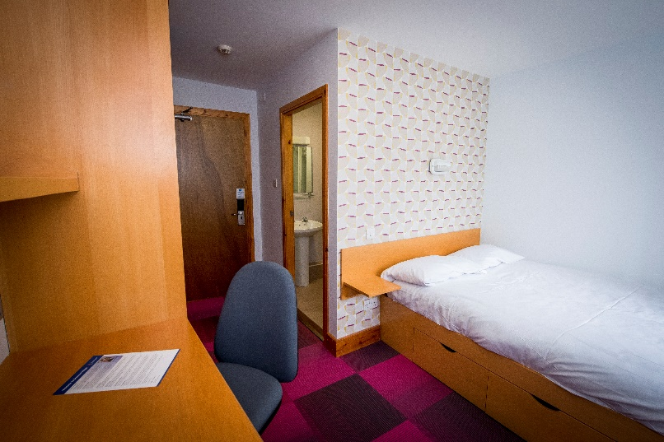

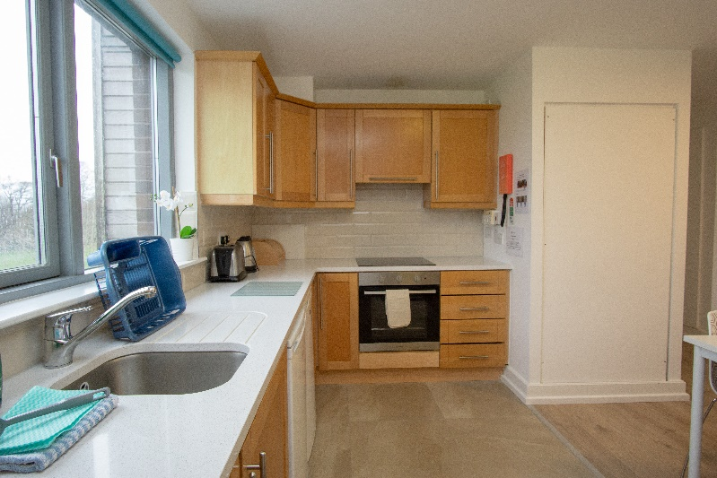

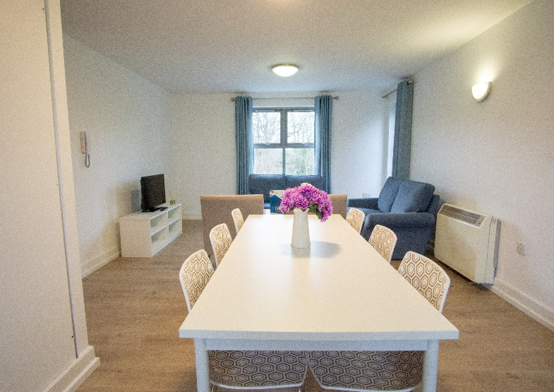

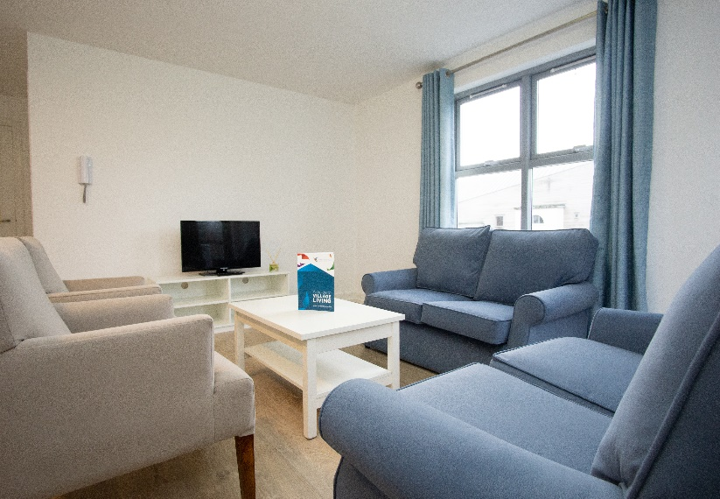

*Please note all beds are 4’6 doubles and cannot be split into twin configuration

Thomond Village – University of Limerick

* Single Room price: €70.00 - Based on one person per room per night
* Double Room price: €90.00 - Based on 2 guests sharing one room pn  
  **Please note all beds are 4’6 doubles and cannot be split into twin configuration**
* Number of rooms: 50 Single 10 Double
* Board plan: Room only
* Check-in from 3pm, Wednesday June 9th 2021
* Latest check-out 10am sharp, Monday June 14th 2021
* Hotel website: [www.conference.ul.ie](http://www.conference.ul.ie)

Thomond Village is located on the North Campus of the University of Limerick, just a short stroll from the main campus. Accommodation is offered in apartments, comprising of **4 private en-suite bedrooms**, a **shared** spacious living area with smart TV and **shared** fully equipped kitchen. Free Wi-Fi is available throughout the campus.

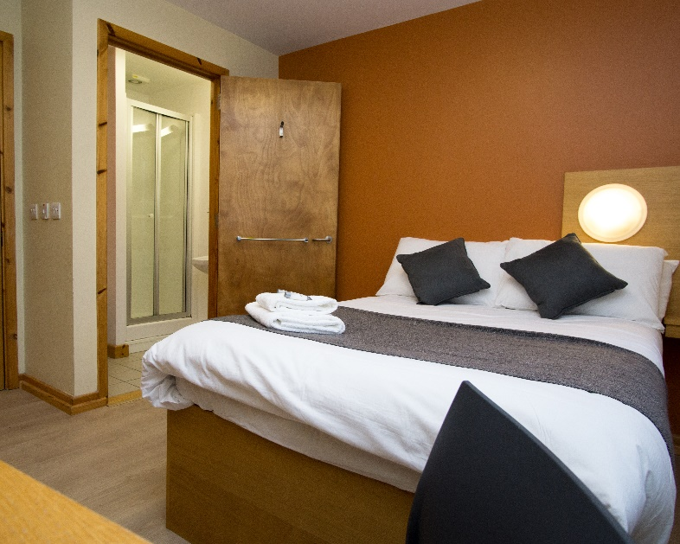

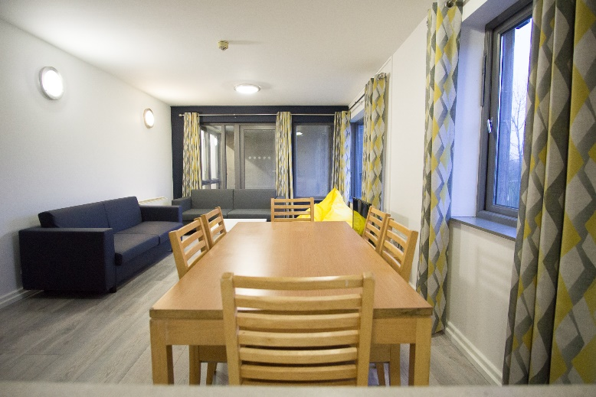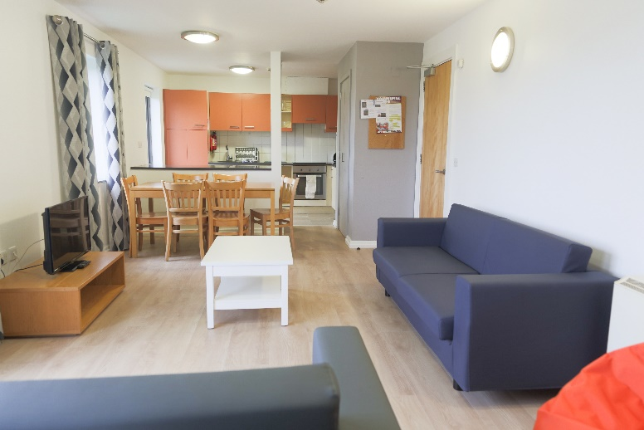

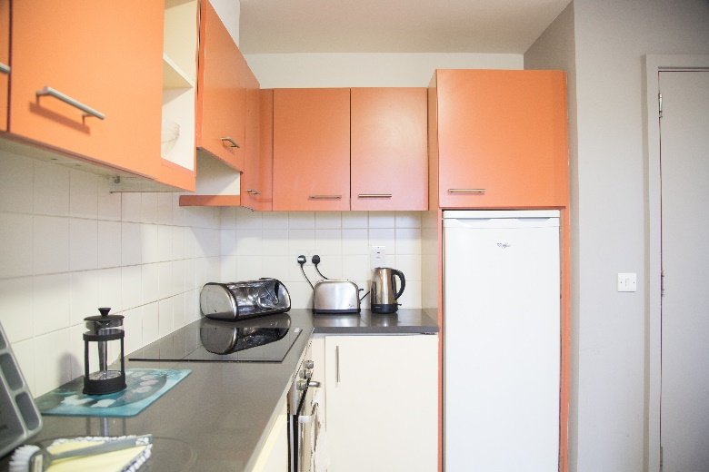

*Please note all beds are 4’6 doubles and cannot be split into twin configuration

Accommodation is allocated on a first come, first served basis. Accommodation rate does not include catering. There is a variety of dining options within a short walking distance to the competition venue.

**Teams who do not reserve their accommodation through the organizing committee will be charged a double entry fee.**

* Final Hotel Reservation & Transportation before 1st May 2021

Important Note: Please refer to the accommodation pages above for detailed accommodation information. Complete all necessary sections in WAREOS and make full payment for entries and accommodation by the specified deadlines. Bank transfers only, no credit cards will be accepted.

In addition, the LOC will not be responsible to provide any event information at this accommodation or provide transportation to the venues.

Teams that book non-official accommodation will need to register at the accreditation desk no later than the morning of official practice day. Failing to do so will result in no changes being made to the entry list and it is likely that participation in the event will be refused if registration is not completed in time.

ENTRY FEE

|  |  |
| --- | --- |
| Individual: | **165 euro** per athlete |
| Officials: | **70 euro** per person |
| Team Registration | €30 per team. |
| Temporary Upgrade:  For athletes wishing to be a coach temporarily | **30 euro** per accreditation |
| Airport Transfer | **33 per person one way (Shannon Airport only)** |
|  |  |

Entry fee in NON-official hotels:

Individual: **330 euro** per athlete

Officials: **140 euro** per person

PAYMENT CONDITIONS:

To confirm hotels reservations, a payment of the total amount is required to be bank transferred to the LOC before **9th** **May 2021**. Reservations after this date will be considered only according to availability. The final outstanding balance shall be made via bank transfer before arrival. Accommodation cannot be guaranteed after this deadline. A balanced invoice will be provided via WAREOS.

BANK INFORMATION for ACCOMMODATION, TRANSPORTATION and

ENTRY FEES:

A/C Name: Aimwell Events LTD

Telephone number: 0876459583

City and Country: Dublin Ireland

Bank: AIB

Account Number: 48771093  
IBAN: IE67AIBK93340648771093

BIC: AIBKIE2D

Bank’s address: AIB Bank, The Park, Carrickmines Dublin 18 Ireland

Bank’s Phone: 00353 12903700

City: Dublin Ireland

**NOTE**: ALL PAYMENTS SHALL BE MADE IN EURO BY BANK TRANSFER.

All bank charges will be paid by the participants. CREDIT CARDS are not accepted.

Cancellations & Changes

All cancellations and changes must be made through WAREOS:

* Cancellations received **before** 1st May 2021 will receive a full refund of the deposit payment will be made.
* For cancellations received **after** 1st May 2021, no refund will be given.
* Refunds will be processed after the event takes place.
* Name changes to team officials or athletes (same category and division) will be accepted up to **two (2) days before official practice** without any additional charge or penalty fees.
* Should flight arrival details change last minute, please contact the Organising Committee using the details indicated in the team managers’ booklet.
* If a participant’s arrival is later than the original scheduled arrival date, the room will be charged from the date of the original booking in WAREOS.
* An email will automatically notify the Organising Committee and Member Association of any changes made in WAREOS.

ADDITIONAL INFORMATION

Transportation

Transportation can be provided from Shannon airport to the official accommodation, from one day before the official practice day to one day after the closing day.   
Shannon Airport transfers cost €66 per person return.

Training

No training field will be available until official practice on the 10th June 2021.

Weather

Limerick average High temperatures for June are 17.9 to lows of 9.6

It rains on average 7.4 days in June  
https://www.holiday-weather.com/limerick/averages/june/

Media Registration

Media representatives can apply for registration by emailing [info@archery.sport](mailto:info@archery.sport)

Internet

Will be available in the official accommodation free (in accommodation rooms and living areas)

Water

Water will be available at the qualification/practice venue.

Visa

All participants who need an entry visa to Ireland, will be required to complete the **Visa Support sections** in WAREOS by no later than 19th March 2021.

It is the applicants’ responsibility for supplying the necessary information, ensuring all details are up to date, correct and submitted by the deadlines specified.

In addition, all participants that require a visa are kindly requested to supply a copy of their latest/valid passport. Copies of each application can be uploaded on WAREOS. All passport copies and personal details entered/uploaded to WAREOS will be held securely and in the strictest of confidence and not shared with other parties.

LOC CONTACT

Name: Adam Taylor

Email: info@emeraldislecup.com

Language: English

Phone number with international extension: +353876459583