Hyundai World Archery Championships

Invitation Package
TO ALL World Archery MEMBER ASSOCIATIONS

Dear President,

On behalf of the Local Organizing Committee (LOC) of the Hyundai World Archery Championships 2019, ‘s-Hertogenbosch – Netherlands, we would like to invite your country to the Hyundai World Archery Championships 2019, which will be held from 9 to 16 June in ‘s-Hertogenbosch – Netherlands.

Please find enclosed the necessary information for registration, organization and participation for this event. Please complete all the necessary details in WAREOS before the following deadlines:

Summary of deadlines:
- Preliminary Entries 11 March 2019
- Final Entries 19 May 2019
- Hotel Reservation 8 February 2019
- Transportation 30 April 2019
- Visa Support 1 April 2019
- Final Hotel Reservation 1 April 2019
& Payment

We will host the 2019 World Archery Congress (1–2 June) and the 2019 Para World Archery Championships (2-9 June) prior to the Hyundai World Archery Championships. A separate invitation package will be available to our Member Associations to register their attendance to both events.

Please note that accreditation for the World Archery Congress is not valid as accreditation for the Championships, as a separate team official registration is required for the event. For ticket information please check our website.

We are looking forward to welcoming you and your teams, to ‘s-Hertogenbosch – The Netherlands.

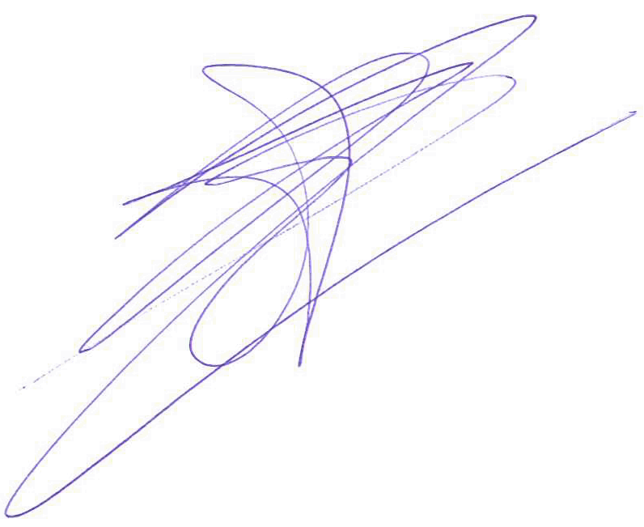
Sincerely yours,

Mr. Eric Kersten
President Organizing Committee

PRELIMINARY PROGRAMME
Day |  |  | Date | Description
Day -2 | Friday  7 June |  |  | Arrival of participants  Practice field and local transport available
DAY -1 | Saturday  8 June |  |  | Arrival of Participants  Practice field and local transport available
DAY 0 | Sunday  9 June |  |  | - Official Practice Recurve (women and men)  - Official Practice Compound (women and men)  - Registration and Equipment Inspection  - Team Managers Meeting  - Opening of the Championships
DAY 1 | Monday  10 June |  |  | Qualification Round and Mixed Team Eliminations
DAY 2 | Tuesday  11 June |  |  | Qualification Round and Individual Eliminations
DAY 3 | Wednesday  12 June |  |  | Team, Mixed Team and Individual Eliminations  - Recurve (women and men)  - Compound (women and men)
DAY 4 | Thursday  13 June |  |  | Individual and Team Elimination  - Recurve (women and men)  - Compound (women and men)
DAY 5 | Friday  14 June |  |  | Olympic Secondary Qualification Tournament for Tokyo 2020
DAY 6 | Saturday  15 June |  |  | Finals Compound  - Team Medal Matches  - Mixed Team Medal Matches  - Individual Medal Matches  - Awards Ceremony
DAY 7 | Sunday  16 June |  |  | Finals Recurve  - Team Medal Matches  - Mixed Team Medal Matches  - Individual Medal Matches  - Awards and Closing Ceremony
DAY 8 |  | Monday  17 June |  | Departure of teams

NOTE: This preliminary programme could be changed slightly according to number of participants and TV requirements. All changes will be published and distributed to all participants in good time.
PRELIMINARY & FINAL REGISTRATION
All entries, accommodation reservations, transport needs, flight arrival/departure information and visa invitation letter requests are to be completed using WAREOS.

The World Archery Online Registration System (WAREOS): http://extranet.worldarchery.org has been updated to handle the entire registration process for this event. No entry forms, hotel reservations or transport forms will be accepted as all information is to be entered into to WAREOS.

In order to use WAREOS, please login on http://extranet.worldarchery.org with your Username and Password assigned by World Archery. After entering WAREOS, please go to "Online Registration" and register your athletes and officials for this event. A "WAREOS User Manual" can be downloaded in PDF format (English) using the same website link.

For any questions regarding WAREOS, please contact the World Archery office, Mr. JK LEE (jklee@archery.org).

A maximum number of 3 athletes per country is allowed to be registered into each category of the event. Preliminary entries should be completed using WAREOS.

Start date for online registration using WAREOS 1 December 2018
End of Preliminary registration using WAREOS: 11 March 2019
End of Final registration using WAREOS: 19 May 2019

Please respect the stated deadlines.

Member Associations should only use WAREOS to make any changes/amendments to their entries and will be able to do so at any time. Any changes made in WAREOS an email will instantly be automatically sent to the Local Organising Committee and Member Association with the updated information.

However, any changes that are made after the deadlines specified or if entries differ by more than 4 athletes from the preliminary entries, the following penalty fees will automatically be applied.

Penalty fees to be paid to Organising Committee: | Cost (EUR):
Entries made after the entry deadline date. | 45 per entry
If final entries differ from the preliminary entries by more than 4 athletes/officials. | 140 per entry
When no preliminary entries were made before the deadline date but then submit final entries. | 140 per entry

Penalty Fee to be paid to World Archery: | Cost (CHF):
Lost accreditation. | 30 each
Changes made to the athlete and/or team official names after the final entry deadline date and within 3 days prior to the start of the event. | 50 each change

NOTE: CHF currency exchange rates will be those on the date of the event.

Member Associations that have penalty fees outstanding from earlier events will need to have paid these penalty fees before being eligible to enter and compete.

Any entries received less than 3 days before the team managers meeting for a Hyundai Archery World Cup or World Championships will be refused if no preliminary entry and/or final entry are made prior. This decision cannot be appealed by the teams and is fully compliant with the current World Archery rules, article 3.7.1.2. Entries received after the deadlines, are subject to penalties as clearly stated in the rule book and the invitation documents of World Cups and World Championships. A Member Association that has made final entries in WAREOS and does not participate will be invoiced for the number of entries entered in the system, unless they have informed World Archery and the OC in writing at least one week prior to the event that they are unable to attend

ACCOMMODATION & GENERAL INFORMATION
The official hotels are divided in three categories: Standard, Comfort and Superior. All hotels are especially selected by the organization for the World Archery Championships. Upon your arrival you will immediately encounter the famous Brabant hospitality and feel at home. Hotel allocations will be made on a “first come, first serve” basis. Accommodation rates will offer various meal packages, such as full board, half board and bed and breakfast with non-alcoholic drinks to match varying budgets.

Teams that book their own accommodation in hotels not arranged by the Organising Committee will be charged a double entry fee.
- Reservations should be made before 8 February 2019
- Final Hotel Reservation & Transportation Forms: 1 April 2019

To confirm your hotel reservations, a 60% deposit, of the total amount, is to be paid by a bank transfer to the Organizing Committee before 8 February 2019. Reservations received after this date will be considered only according to availability.

- Standard Hotels
Breakfast only
Single Room 125 EUR
Double/Twin 85 EUR
Half board (Breakfast at the hotel, lunch at the venue)
Single Room 145 EUR
Double/Twin 105 EUR
Full board (Breakfast at the hotel, lunch and dinner at the venue)
Single Room 165 EUR
Double/Twin 125 EUR

2. Comfort Hotels
Breakfast only
Single Room 155 EUR
Double/Twin 100 EUR
Half board (Breakfast at the hotel, lunch at the venue)
Single Room 170 EUR
Double/Twin 120 EUR
Full board (Breakfast at the hotel, lunch and dinner at the venue)
Single Room 190 EUR
Double/Twin 140 EUR

3. Superior Hotels
Breakfast only
Single Room 180 EUR
Double/Twin 115 EUR
Half board (Breakfast at the hotel, lunch at the venue)
Single Room 200 EUR
Double/Twin 135 EUR
Full board (Breakfast at the hotel, lunch and dinner at the venue)
Single Room 220 EUR
Double/Twin 155 EUR

The hotel room rates are per person, per night and including free internet. Depending on the package including breakfast at the hotel, lunch and dinner at the venue. Additional purchases in the hotel bar, café and mini bar is at own expense. *All prices are including city tax.

One limited edition event gadget per person is included.

All teams that book their accommodation package through the LOC receive one parking tickets per country for the St. Jan’s parking garage (located under the training venue, Hekellaan 25, ‘s-Hertogenbosch, the maximum clearance in the parking garage is 2.10 meters) and transport to and from the venue to and from the official hotel during the qualification, elimination and final days is included. Timetable to be confirmed on site.

*No transportation available to and from Golden Tulip Hotel Central. Golden Tulip Hotel Central is located on walking distance of the venue.

During the event there is a tournament desk available in all official hotels with all the relevant and latest information about the World Championships.

Please refer to the accommodation page below for the hotels per category. For detailed hotel information check the official event website: www.archery2019.com/Archery/Hotel.aspx

- Standard Hotels
Standard hotels are good hotels with all the basic needs. A little bit further away located from the World Championships Venue. Do you need a little extra? Please check out the comfort hotels.
Guldenberg Hotel***
Fletcher Hotel Boschoord***
Hotel Waalwijk****
Hotel De Naaldhof****

2. Comfort Hotels
Comfort hotels give you just a little more extra comfort. Located more closer to the World Championships venue. Do you still need a little extra? Please check out the superior hotels.
NH Hotel Waalwijk****
Landgoed Huize Bergen****
Fletcher Hotel ‘s-Hertogenbosch****

3. Superior Hotels
Located close to the venue, luxury hotels gives you the ultimate comfort.
De Ruwenberg Hotel (Official World Archery Hotel) ****
Van der Valk Hotel ’s-Hertogenbosch ****
Mövenpick Hotel ‘s-Hertogenbosch ****
Golden Tulip Hotel Central ****

Important Note:
Please refer to the accommodation pages for detailed hotel information. Please complete all the necessary sections in WAREOS and make full payment for entries, transport and accommodation by the specified deadlines. Bank transfers only, no credit cards or travel checks will be accepted.

Participants who book their accommodation in non-official hotels will need to pay a double entry fee. In addition, the LOC will not be responsible to provide any event information at this hotel or provide transportation to the venues.

Teams that book non-official accommodation will need to register at the Championships accreditation office no later than the day before official practice day. Failing to do so will result in changes being made to the entry lit and it is likely that participation in the event will be refused if registration is not competed in time.

1. Standard Hotels
Guldenberg Hotel***
Hotel Guldenberg is surrounded by the beautiful nature, located on a short distance from Drunen National Park. A quiet area to relax.
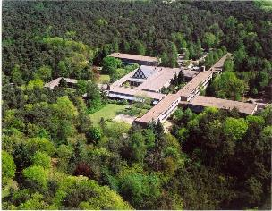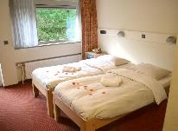
Fletcher Hotel Boschoord***
Not far from 's-Hertogenbosch and hidden among the beautiful forests on the edge of Oisterwijk, lies the 3-star Fletcher Hotel-Restaurant Boschoord. The hotel is situated in a quiet area but also has the typical cosiness of Brabant.
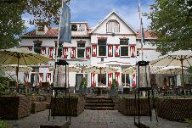
Fletcher Hotel Waalwijk****
Fletcher Hotel Waalwijk is situated only a 20 minute drive from ‘s-Hertogenbosch. Located close to nature parc Dunes of Loon and Drunen national Park. The hotel is the base for a relaxing and enjoyable stay.
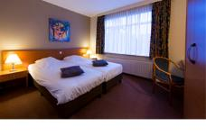

Hotel De Naaldhof****
Hotel de Naaldhof is a very multi-functional hotel in the direct surroundings of Den Bosch. A unique hotel in which hospitality has a high standard.
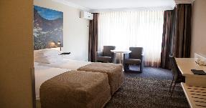
2. Comfort Hotels
NH Hotel Waalwijk****
NH Waalwijk is situated only a 20 minute drive from ‘s-Hertogenbosch and is located on a short distance from nature parc Dunes of Loon and Drunen National Park. An ideal place to relax, but also to have your daily work-out.
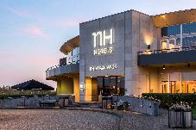
Landgoed Huize Bergen****
Landgoed Huize Bergen is located near 's-Hertogenbosch hidden in a beautiful park between ancient trees. Here surrounded by nature it is wonderful to relax and unwind after an intensive day.
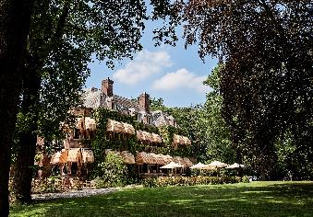

Fletcher Hotel ‘s-Hertogenbosch****
On the edge of the Burgundian city of 's-Hertogenbosch lies the 4-star Fletcher Hotel-Restaurant 's-Hertogenbosch in Rosmalen. The luxurious hotel is the ideal base for a relaxing and enjoyable stay.
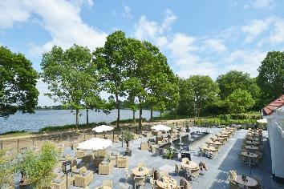

3. Superior Hotels
De Ruwenberg Hotel (Official World Archery Hotel) ****
The castle "De Ruwenberg" dates from the 14th century and is situated in a wooded, inspiring and relaxing environment. De Ruwenberg stands for quality, hospitality, sustainability and inspiration.
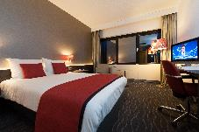

Van der Valk Hotel ’s-Hertogenbosch ****
Van der Valk Hotel 's-Hertogenbosch-Vught is a professional and flexible partner for a stay during the Archery World Championships. Except comfortable hotel rooms the hotel offers a wide range of sports facilities, varied sports meals, laundry and dry cleaning service.

Mövenpick Hotel ‘s-Hertogenbosch ****
Mövenpick Hotel 's-Hertogenbosch 4-star hotel located on the waterfront just outside the historic centre of Den Bosch. Enjoy a snack and a drink on the terrace by the water in summer.

Golden Tulip Hotel Central ****
This isn’t a hotel, this is like coming home. Luxuriating in Brabant at its best. Where everything and everyone is aimed at making your stay wonderful. From the moment you are welcomed to the final ‘Goodbye!’ This is more like staying with friends. In ’s-Hertogenbosch’s city centre. It doesn’t get any more central than this.
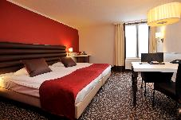
*No transportation available to and from Golden Tulip Hotel Central. Golden Tulip Hotel Central is located on walking distance of the venue.

ENTRY FEE
Entry fee:
Individual: 230 Euros per athlete
Officials: 115 Euros per person
Temporary Upgrade: 30 CHF per accreditation (for athletes wishing to be a coach temporarily).

Entry fee in NON official hotels:
Individual: 460 Euros per athlete
Officials: 230 Euros per person

There is no entry fee for teams.

PAYMENT CONDITIONS:
All fees should be paid in full before arrival.

Payment of accommodation and local transportation: a minimum deposit of 60% of the total amount owed should be made when booking by 8 February 2019. The final outstanding balance shall be transferred before arrival. Accommodation cannot be guaranteed after this deadline. A balance invoice will be provided via WAREOS.

BANK INFORMATION for ACCOMMODATION, TRANSPORTATION and
ENTRY FEES:
BANK: RABOBANK Oss Bernheze
ADDRESS: Postbus 20, 5384 ZG Heesch
BANK ACCOUNT HOLDER NAME: The Event Connection B.V.
ACCOUNT NO: NL83 RABO 0125 5232 54
BIC/SWIFT CODE: RABONL2U

NOTE: All payments shall be made in EUR by BANK TRANSFER.

Bank transfer fees are responsible on the SENDER.
CREDIT CARDS and TRAVEL CHECKS will not be accepted.

ADDITIONAL INFORMATION
Transport
There is lots of traffic between Amsterdam Schiphol airport and s-Hertogenbosch, therefore, teams are strongly advised to use the train.

Public transport
Train from Amsterdam Schiphol airport to the Central station of ‘s-Hertogenbosch. One-way ticket will cost around € 18, (2nd class ticket), around € 28, (1st class ticket).

Volunteers from the organizing committee will be at Schiphol airport to meet, greet and provide assistance in purchasing a train ticket, guide you to the correct platform for the train to ‘s-Hertogenbosch.

Upon arrival at ‘s-Hertogenbosch central train station, you will be met again by volunteers from the organising committee who will assist you with transport to the congress hotel. There are taxi’s available at ‘s-Hertogenbosch central station to travel from the railway station to your hotel. Payment can be done cash or by card. For more information about traveling by train, check the website www.ns.nl/en.

Airport transfer
Alternatively, you can reserve a dedicated pick up and drop off (round trip) service from and to the airport with our travel partner, Arriva. Bookings can be made in WAREOS.

Amsterdam Schiphol Airport – ’s-Hertogenbosch*
 | One-way | Retour
Taxi (max 3 persons) | € 345,- | € 690,-
9 persons van | € 406,- | € 811,-
20 persons bus | € 436,- | € 872,-
50 persons bus | € 478,- | € 956,-

Eindhoven Airport – ’s-Hertogenbosch*
 | One-way | Retour
Taxi (max 3 persons) | € 194,- | € 388,-
9 persons van | € 357,- | € 714,-
20 persons bus | € 406,- | € 811,-
50 persons bus | € 436,- | € 872,-
* prices are per taxi/van/bus

Cancellations & Changes
All cancellations and changes must be made through WAREOS:
- Cancellations received before 08/02/2019 (February 8, 2019) a full refund of the deposit payment will be made.
- Cancellations received after 08/02/2019 (February 8, 2019), no refund will be given.
- Refunds will be processed after the event.
- Name changes to team officials or athletes (same category and division) will be accepted up to 72 hours before the event without any additional charge.
- Should flight arrival details change last minute, please contact the Organizing Committee using the details indicated in the Team Managers’ Booklet.
- If a participant’s arrival is later than the original scheduled arrival date, the room charges will start from the dates of the original booking made by the Member Association.
- Any changes made in WAREOS an email will automatically be sent to the Organizing Committee and Member Association with the updated information.

Training
Training venues will be available starting from 8 June 2019. For those teams wishing to arrive earlier and practice at a local club, please check the contact details on the official event website: http://www.archery2019.com

Internet
Free WIFI will be available in the official hotel (in hotel rooms and in the lobby). There will also be Wi-Fi available for access to results.

Water
Water will be available at the qualification and practice venues.

Media Registration
Media representatives can apply for registration by emailing info@archery2019.com

Weather
Average Temperature 16 º C
Low Temperature 10º C
High Temperature 20º C
Sunshine Hours 6 Hours
Rainfall days 19 days
Sunrise 5.30h
Sunset 22.00h

VISA SUPPORT
All participants who need an entry visa to the Netherlands, will be required to complete the Visa Support Form in WAREOS no later than 1 April 2019.

It is the applicants’ responsibility for supplying the necessary information, ensuring all details are up to date, correct and submitted by the deadlines specified.

In addition, all participants that require a visa are kindly requested to supply a copy of their latest/valid passport. Copies of each applications can be uploaded on WAREOS. All passport copies and personal details entered/uploaded to WAREOS will be held securely and in the strictest of confidence and will not be shared with other parties.

Please note that the Organizing Committee can provide invitation for the period of the Hyundai World Archery Championships only.

LOC Contact:
Name: Manouk van den Elzen
Language: (English and Dutch)

Email: info@archery2019.com
Official website: www.archery2019.com

President Organizing Committee: Eric Kersten
Transport and Hotels: Manouk van den Elzen
Finances: Hanny Vloet

’S-HERTOGENBOSCH
‘s-Hertogenbosch is the capital of the province North Brabant in the south of the Netherlands. ‘s-Hertogenbosch, which means ‘The Dukes Forest’, is colloquially known as Den Bosch. The city is famous for its unique Burgundian culture thanks to its centre packed with unique restaurants and lively cafés. ‘s-Hertogenbosch has a versatile cultural-historical city centre offering churches, museums, sailing trips, guides tours, and many other fascinating places of interest.

Get to know 's-Hertogenbosch better by discovering this city with the tips below:

The Bossche Bol
The Bossche bol is a huge profiterole, larger than a tennis ball, filled with special whipped cream and coated with dark chocolate. An original Bossche bol is created in ‘s-Hertogenbosch, so don’t leave the host city without experiencing its favourite pastry.

Jheronimus Bosch
Jheronimus Bosch is one of the most famous inhabitants ‘s-Hertogenbosch has known. As a painter in the Renaissance, Bosch gained fame for his surreal representations in highly detailed paintings. The Jheronimus Bosch Art Centre in 's-Hertogenbosch is completely dedicated to the life and works of the painter.

Sail the waterways
In the beautiful and historic city centre of ‘s-Hertogenbosch you can discover the river Binnendieze. Sail the waterways of this river in an open-topped boat to see the city’s history, architecture and culture.

Minderbroedersplein
The Minderbroederplein is the square to meet and especially taste the Burgundian lifestyle of ‘s-Hertogenbosch. The square is quiet, but still in the middle of the historic city centre with nice restaurants for a good lunch or dinner.

St. John’s Cathedral
The pride of ‘s-Hertogenbosch can be seen from all corners of the city and it seems as the St. John’s Cathedral tops the sky. The gothic cathedral basilica is richly decorated with 600 symbolical figurines. The St. John’s Cathedral is open for short visits. The Archery2019 Arena will be built on the historic square “the Parade”, situated at the foot of the St. John’s Cathedral.

Visit the official website of the municipality of ‘s-Hertogenbosch for more information about the city: www.bezoekdenbosch.nl/en

GENERAL TERMS AND CONDITIONS - ACCOMMODATION

The Event Connection B.V. – General Terms and Conditions, version February 2018 - Accommodation

Article 1 Applicability
1.1 These general terms and conditions apply to legal and other acts and agreements between the Organiser and the Other Party.

1.2 If any provision of the general terms and conditions proves to be void, this will not affect the validity of the other terms and conditions. In consultation, a provision that is in line with the intention of the parties will then replace the void provision.
1.3 The applicability of the general terms and conditions of the Other Party is explicitly rejected.
1.4 These general terms and conditions may be amended by a mere notification from the Organiser to the Other Party. In the absence of written protest within 30 days after this notification, the amended general terms and conditions will apply from the day of notification to all legal acts and agreements to be concluded and to all agreements in force between the parties and current agreements, insofar as they are executed after the day of notification.
1.5 The deadlines in these general terms and conditions will always be final for the Other Party.
1.6 Provisions of the general terms and conditions may only be derogated from in writing.

Article 2 The formation and content of the agreement
2.1 All offers, quotations, expense budgets, etc. of the Organiser will be subject to contract, unless the Organiser has stated otherwise in writing.
2.2 All information and/or specifications provided by the Organiser are approximate only, unless explicitly stated otherwise in writing.
2.3 The Organiser will be entitled to engage third parties for the performance of the assignment.
2.4 Unless explicitly stated otherwise, any offer from the Organiser will be subject to contract and may still be withdrawn by the Organiser.
2.5 The Organiser will have the right to refuse an application without stating any reasons.
2.6 The agreement between the Organiser and the Other Party will be concluded after the Other Party has submitted the reservation for one or more hotel rooms and the Organiser has confirmed this to the Other Party in writing.
2.7 The reservation is made on the basis of a fully completed reservation form that is submitted to the Organiser.
2.8 This reservation may only be changed with the Organiser’s approval.
2.9 The agreement will only be formed after the Organiser has confirmed the reservation in writing.
2.10 Unless explicitly agreed otherwise between the parties, the Other Party cannot derive any rights in respect of the room(s) assigned to them.

Article 3 Obligations of the Other Party
3.1 The Organiser may deny an Other Party who, in the sole opinion of the Organiser, acts in violation of the agreement (including but not limited to the accommodation’s safety regulations, instructions and house rules) the use of the accommodation with immediate effect.
3.2 The Other Party will be responsible for the actions/omissions of any third parties engaged and/or invited by them.
3.3 The Other Party will be obliged to take out travel and/or cancellation insurance.
3.4 Persons for whom the Other Party has not made any reservations may be removed from the accommodation on the Organiser’s instructions. In the event that the Other Party fails to immediately comply with the above notice, the Organiser will be entitled to remove these persons or have them removed at the Other Party’s expense and risk, without the Other Party being entitled to claim compensation.
3.5 Persons who - in the sole opinion of the Organiser - misbehave in the accommodation (or corresponding spaces) may be denied access by or on behalf of the Organiser with immediate effect.

Article 4 Other Obligations
4.1 Without the written permission from the Organiser, the transfer of all or part of the agreement (or the making available of the rented accommodation) by the Other Party to a third party will not be permitted.
4.2 If the accommodation is not or not fully used, this will be at the Other Party’s expense and risk, and this will not release the Other Party from their payment obligation.
4.3 If the Other Party acts in violation of the agreement, the Organiser will be entitled to terminate the agreement without any judicial intervention being required, in which case the Organiser will retain the right to full payment.
4.4 If the rented accommodation is left unused or is vacated, the Organiser will have the right to make the accommodation available to others.

Article 5 Cancellation of the event
5.1 If an event is cancelled either wholly or partially, the Other Party will not be entitled to compensation, regardless of the cause for the cancellation of the event, unless this is solely attributable to the Organiser due to an intentional act or gross negligence on the part of the Organiser.
5.2 If the full or partial cancellation of the event is communicated in writing within 27 days prior to the first check-in date of the hotel accommodation, the Other Party must make a claim under the travel and/or cancellation insurance taken out by them in advance with respect to any accommodation and usage expenses already paid. In the event of written communication more than 27 days prior to the first check-in date, the payment made will be refunded to the Other Party in accordance with the cancellation provisions of Article 7. The Other Party must make a claim under the travel and/or cancellation insurance with respect to the part of any accommodation and usage expenses paid that is refunded.
5.3 If the Other Party or persons for whom reservations have been made by a third party (including national and international federations, the government or other bodies) are excluded from participation in the event, the Organiser will not refund any accommodation and usage expenses already paid, other than in accordance with the cancellation provisions specified in Article 7.

Article 6. Price, payment
6.1 All (agreed) amounts are exclusive of VAT and any other government levies, unless agreed otherwise in writing.
6.2 The Other Party will be obliged to provide security for the obligations under the agreement at any time on the Organiser’s demand.
6.3 Payment terms of the invoices are 14 days after the invoice date. Payment terms are 8 days if the Organiser has accepted the reservation within one month before the start of an event. The full payment must always be received before the first day of the overnight stay at the latest. The Other Party will be in default by operation of law if payment has not been made within the stated periods. After that, it will owe a contractual interest rate of 1% a month (or part of a month).
6.4 Payment must be made in the manner to be specified by the Organiser.
6.5 The Organiser will not be in default as long as the Other Party has not (completely) fulfilled their obligations.

Article 7 Cancellation provisions for booked accommodation
7.1 After the agreement for the reservation of the accommodation has been formed, it will only be possible to cancel the agreement in writing, and the following cancellation provisions will apply.
- Cancellation from 55 days before check-in: 100% owed
- Cancellation between 109 and 56 days before check-in: 60% owed
- Cancellation up to 110 days before check-in: €75 in administrative costs owed
7.2 If, at the time of cancellation, the Organiser’s loss exceeds the cancellation fee included in Article 7.1 of these general terms and conditions, the Other Party must compensate the Organiser for this amount in excess.
7.3 The Organiser will be entitled to charge to the Other Party all costs, including full extrajudicial costs subject to a minimum of €250.00 excluding VAT and legal costs.

Article 8 Cancellation provisions for meals for the Other Party
8.1 If in the case of a reservation for meals, a (special) menu has been agreed on, the following percentages will be owed upon cancellation by the Other Party:
- Cancellation from 3 days before reservation 100%
- Cancellation between 7 and 4 days before reservation 50%
- Cancellation between 14 and 8 days before reservation 25%
- Cancellation 15 days before reservation 0%
8.2 If in the case of a reservation for meals, no (special) menu has been agreed on, the following percentages will be owed upon cancellation by the Other Party:
- Cancellation from 24 hours (1 day) before reservation 100%
- Cancellation between 1 and 3 days before reservation 50%
- Cancellation between 7 and 4 days before reservation 25%
- Cancellation up to 8 days before reservation 0%

Article 9 Cancellation provisions for meals for the Organiser
9.1 With due observance of the following, the Organiser will be authorised to cancel an agreement for the delivery of meals, unless the customer has given notice in writing within seven days after the conclusion of the agreement in question that they waive their own right of cancellation.
9.2 The Organiser will at all times be authorised to cancel a meal reservation if there are clear indications that the meeting has such a different nature from that of which the Other Party has informed the Organiser and as a result of which the Organiser would not have concluded the agreement had it been aware of the actual nature of the meeting. If the Organiser exercises this authority after the relevant meeting has started, the Other Party will be obliged to pay for the services enjoyed until that time, but their payment obligation in all other respects will lapse. The fee for services enjoyed will be calculated in proportion to their use or time, where appropriate.
9.3 Instead of exercising its authority referred to in Article 9.2, the Organiser will be entitled to set further conditions for the course of the meeting in question. If there are sufficient indications that these requirements are not or will not be complied with, the Organiser will still be entitled to exercise the authority referred to in Article 9.2.

Article 10 The Organiser’s liability
10.1 The Organiser will only be liable for damage or loss (i) if this damage or loss is covered by the liability or other insurance, and in that case up to the amount paid out by the insurance, if the insurance company pays out, plus the excess or (ii) in case of an intentional act or gross negligence. If the insurance company does not pay out, the Organiser will be liable at most for the damage or loss up to the amount of the booked accommodation.
10.2 If the Organiser is liable, this liability will be limited to direct damage or loss and it will in no event include indirect damage or loss and/or consequential damage or loss.
10.3 Notice of the exercise of all rights of action and other authorities, of any nature whatsoever, which the Other Party has vis-à-vis the Organiser, must have been received by the Organiser in writing within 12 months after the time that the Other Party became or could reasonably have been aware of them, in the absence of which they will lapse.
10.4 All guests of the Other Party will be present at their own expense and risk. Neither the Organiser nor the owner of/party entitled to the accommodation will be liable for any damage to property or for accidents of the Other Party or guests, unless the damage has been caused as a result of an intentional act or gross negligence on the part of the Organiser.
10.5 The Other Party indemnifies the Organiser against third-party claims (including but not limited to participants and visitors), who suffer damage or loss in connection with the performance of the agreement.

Article 11 Applicable law and competent court
11.1 Dutch law applies exclusively to all legal relationships between the Organiser and the Other Party.
11.2 The Court of Oost-Brabant has exclusive jurisdiction to hear disputes between the parties, to the extent that mandatory statutory provisions do not oppose this.

