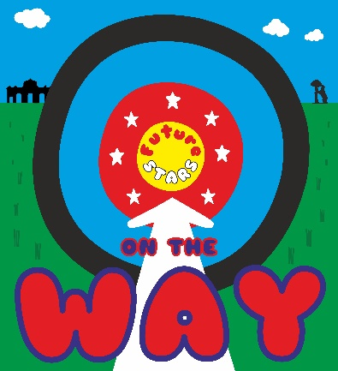
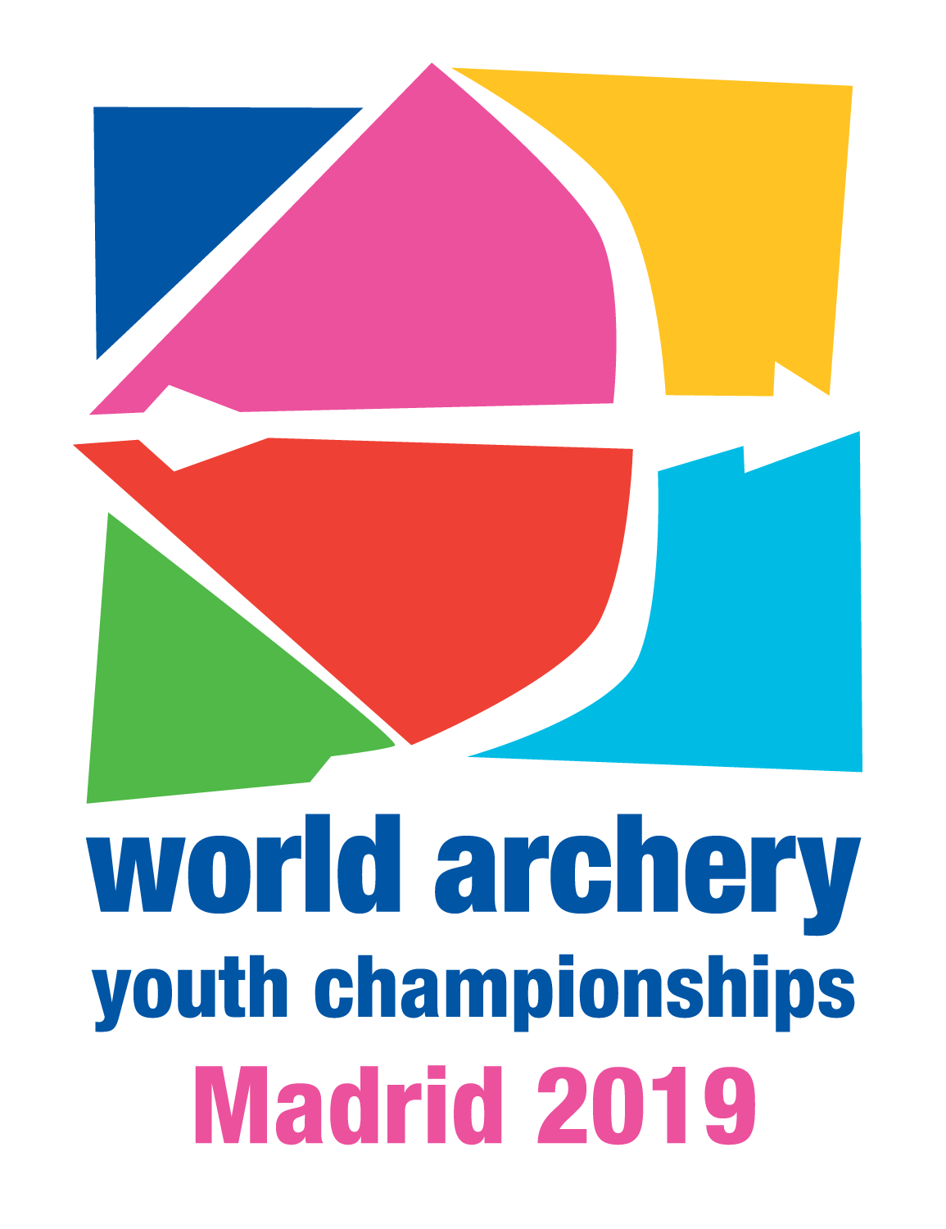

2019 WORLD ARCHERY
YOUTH CHAMPIONSHIPS

INVITATION PACKAGE

TO ALL World Archery MEMBER ASSOCIATIONS

Dear President,

On behalf of the Spanish Archery Federation, as the Local Organizing Committee (LOC) of the 2019 Youth World Archery Championships, Madrid – Spain, we would like to invite your country to the 2019 Youth World Archery Championships, which will be held from 19 to 25 August in Madrid – Spain.

Please find enclosed the necessary information for registration, organization and participation for this event. Please complete all the necessary details in WAREOS before the following deadlines:

Summary of deadlines:
- Preliminary Entries 21 May 2019
- Final Entries 29 July 2019
- Accommodation Reservation Check accommodation details
- Visa Support 17 May 2019
- Transportation 5 July 2019
- Final Hotel Reservation 5 July 2019
& Payment

We are looking forward to welcoming you and your teams, to the vibrant city of Madrid - Spain.

Sincerely yours,
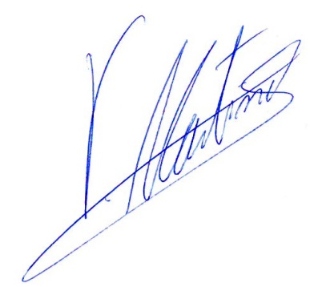

Mr. Vicente Martinez Orga
President of the Spanish Archery Association

PRELIMINARY PROGRAMME
Day |  |  | Date | Description
DAY -2 | Saturday  17 August |  |  | Arrival of Participants  Practice field and local transport available  Registration and accreditation
DAY -1 | Sunday  18 August |  |  | Arrival of participants  Practice field and local transport available  Registration and accreditation
DAY 0 | Monday  19 August |  |  | - Official Practice Recurve (women and men)  - Official Practice Compound (women and men)  - Registration and Equipment Inspection  - Team Managers Meeting  - Opening of the Championships
DAY 1 | Tuesday  20 August |  |  | Qualification Round and Individual Eliminations
DAY 2 | Wednesday  21 August |  |  | Team and Individual Eliminations  - Recurve (women and men)  - Compound (women and men)
DAY 3 | Thursday  22 August |  |  | Individual and Team Elimination  - Recurve (women and men)  - Compound (women and men)
DAY 4 | Friday  23 August |  |  | Mixed Team Eliminations  - Recurve (men and women)  - Compound (men and women)
DAY 5 | Saturday  24 August |  |  | Finals Compound  - Team Medal Matches  - Mixed Team Medal Matches  - Individual Medal Matches  - Awards Ceremony
DAY 6 | Sunday  25 August |  |  | Finals Recurve  - Team Medal Matches  - Mixed Team Medal Matches  - Individual Medal Matches  - Awards and Closing Ceremony
DAY 7 |  | Monday  26 August |  | Departure of teams
NOTE: This preliminary programme could be changed slightly according to number of participants and TV requirements. All changes will be published and distributed to all participants in good time.
PRELIMINARY & FINAL REGISTRATION
All entries, accommodation reservations, transport needs, flight arrival/departure information and visa invitation letter requests are to be completed using WAREOS.

The World Archery Online Registration System (WAREOS): http://extranet.worldarchery.org has been updated to handle the entire registration process for this event. No entry forms, hotel reservations or transport forms will be accepted as all information is to be entered into to WAREOS.

In order to use WAREOS, please login on http://extranet.worldarchery.org with your Username and Password assigned by World Archery. After entering WAREOS, please go to "Online Registration" and register your athletes and officials for this event. A "WAREOS User Manual" can be downloaded in PDF format (English) using the same website link.

For any questions regarding WAREOS, please contact the World Archery office, Mr. JK LEE (jklee@archery.org).

A maximum number of 3 athletes per country is allowed to be registered into each category of the event. Preliminary entries should be completed using WAREOS.

Start date for online registration using WAREOS 11 March 2019
End of Preliminary registration using WAREOS 21 May 2019
End of Final registration using WAREOS 29 July 2019

Please respect the stated deadlines.

Member Associations should only use WAREOS to make any changes/amendments to their entries and will be able to do so at any time. Any changes made in WAREOS an email will instantly be automatically sent to the Local Organising Committee and Member Association with the updated information.

However, any changes that are made after the deadlines specified or if entries differ by more than 4 athletes from the preliminary entries, the following penalty fees will automatically be applied.

Penalty fees to be paid to Organising Committee: | Cost (EUR):
Entries made after the entry deadline date. | 45 per entry
If final entries differ from the preliminary entries by more than 4 athletes/officials. | 140 per entry
When no preliminary entries were made before the deadline date but then submit final entries. | 140 per entry

Penalty Fee to be paid to World Archery: | Cost (CHF):
Lost accreditation. | 30 each
Changes made to the athlete and/or team official names after the final entry deadline date and within 3 days prior to the start of the event. | 50 each change

NOTE: CHF currency exchange rates will be those on the date of the event.

Member Associations that have penalty fees outstanding from earlier events will need to have paid these penalty fees before being eligible to enter and compete.

Any entries received less than 3 days before the team managers meeting for a Hyundai Archery World Cup or World Championships will be refused if no preliminary entry and/or final entry are made prior. This decision cannot be appealed by the teams and is fully compliant with the current World Archery rules, article 3.7.1.2. Entries received after the deadlines, are subject to penalties as clearly stated in the rule book and the invitation documents of World Cups and World Championships. A Member Association that has made final entries in WAREOS and does not participate will be invoiced for the number of entries entered in the system, unless they have informed World Archery and the OC in writing at least one week prior to the event that they are unable to attend

ACCOMMODATION & GENERAL INFORMATION
The following are the official accommodation options for the championships.

MAIN VILLAGE - UNIVERSITY ACCOMMODATION BUILDINGS

All four buildings are very close to the main competition field, taking just 15’ walking or less than 5 minutes by bus (transportation provided by the LOC)

They all provide full board, free Wi-Fi, and meeting rooms (under request).
Bed linen and towels are also included.

Coin-operated washing machines are available in all buildings.
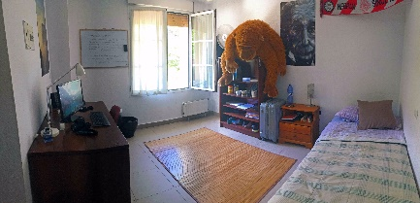
ANTONIO NEBRIJA
- Capacity: 99 single & 8 double rooms
- Single Room 135,00€
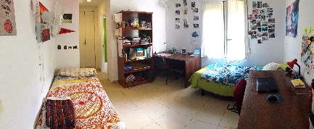
- Double room 75,00€ per person
- Reservations deadline: May 17th, 2019
- https://www.ucm.es/visita-virtual-cm-antonio-de-nebrija

DIEGO DE COVARRUBIAS
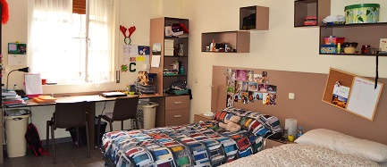
- Capacity: 68 single & 35 double rooms
- Single Room 135,00€
- Double room 75,00€ per person
- Reservations deadline: May 17th, 2019
- https://www.ucm.es/visita-virtual-cm-diego-de-covarrubias

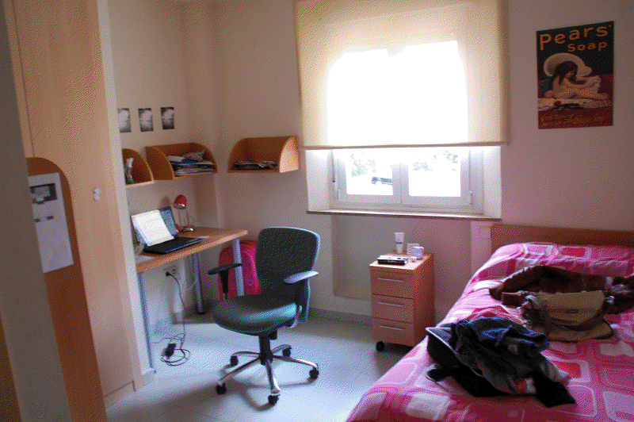
TERESA DE JESÚS
- Capacity: 116 single & 17 double rooms
- Single room: 135,00€
- Double room: 75,00€ per person
- Reservations deadline: May 17th, 2019
- https://www.ucm.es/visita-virtual-cm-teresa-de-jesus

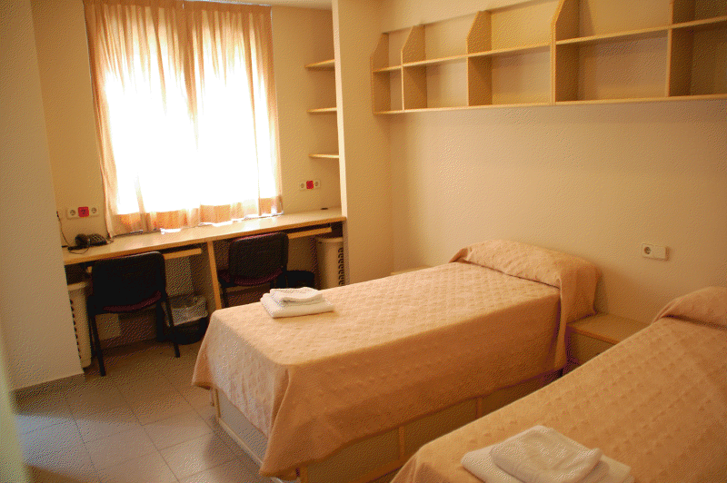
XIMÉNEZ DE CISNEROS
- Capacity: 120 single & 12 double rooms
- Single Room 135,00€
- Double room 75,00€ per person
- Reservations deadline: May 17th, 2019
- https://www.ucm.es/visita-virtual-cm-ximenez-de-cisneros

SANTA MARÍA DE EUROPA UNIVERSITY ACCOMMODATION BUILDING
- Capacity: 115 single & 47 double rooms
- Single room: 135,00€
- Double room: 75,00€ per person
- Reservations deadline: May 17th, 2019
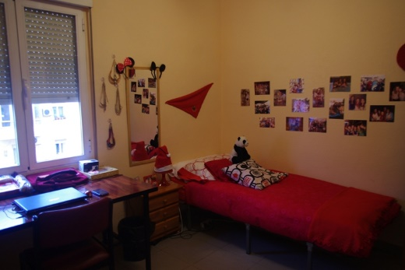
- https://www.ucm.es/visita-virtual-cm-santa-maria-de-europa
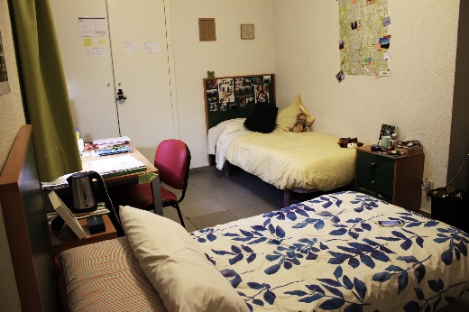

This building is 30 minutes walking distance from the main competition area, 10 minutes by bus (transportation provided by the LOC).
Prices are full board, providing free Wi-Fi, meeting rooms (under request), bed linen and towels. Coin-operated washing machines are also available.

HOTEL EXE MONCLOA (4* HOTEL)
- Capacity: 30 rooms
(to be increased, under request, according to hotel’s availability)
- Single room: 235,00€
- Double room: 145,00€ per person
- Triple room: 100,00€ per person
- Dinner service in the hotel: 35,00€
- Reservations deadline: March 24th, 2019
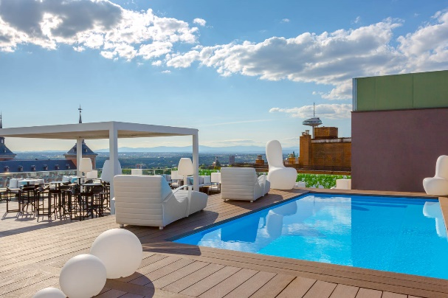
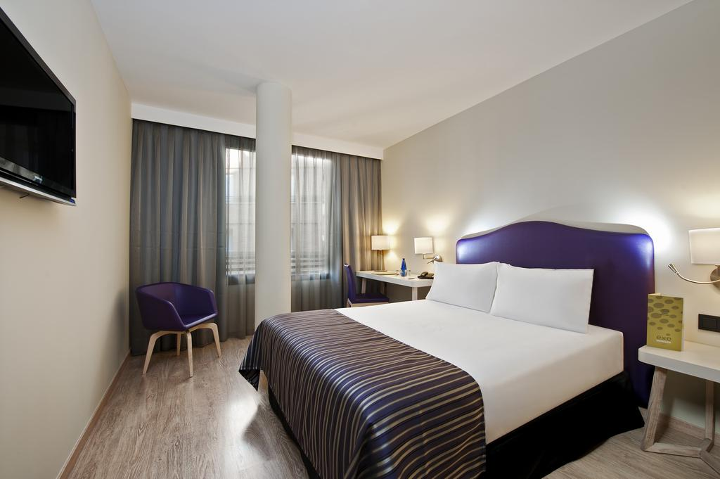

The hotel is 25 minutes walking distance from the main competition area, 7 minutes by bus (transportation is provided by the LOC)
Prices include accommodation, breakfast and lunch near the competition area.
Wi-Fi and swimming pool are available for guests.
COURTYARD BY MARRIOTT MADRID PRINCESA (4* HOTEL)
- Capacity: 30 rooms
(to be increased, under request, according to hotel’s availability)
- Single room: 250,00€
- Double room: 160,00€ per person
- Triple room: 125,00€ per person
- Dinner service in the hotel: 30,00€
- Reservations deadline: April 12th, 2019

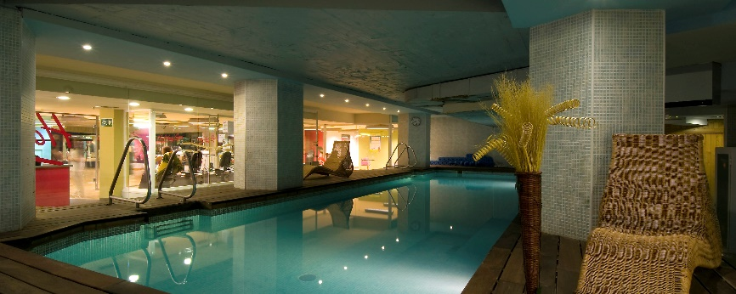
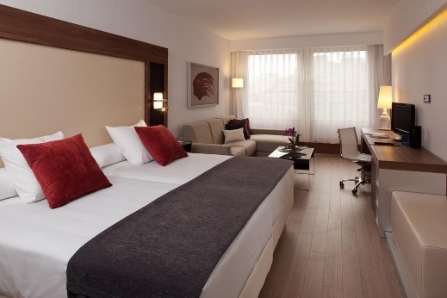
The hotel is 35 minutes walking distance from the main competition area, 10 minutes by bus (transportation is provided by the LOC).
Prices include accommodation, breakfast and lunch near the competition area.
Wi-Fi, swimming pool and gym are available for guests.

All accommodation rates are per person, per night and including breakfast, free internet and lunch close to the competition area.
Additional purchases in the hotel bar, café and mini bar is at own expense.
*All prices are including city tax.

During the event there will be information desks available in all official hotels with all the relevant and latest information about the World Championships.

Teams who do not reserve their accommodation through the organising committee will be charged a double entry fee.
- Check each accommodation building reservation deadline
- Final Hotel Reservation & Transportation before July 5th, 2019.

To confirm hotels reservations, a minimum 50% deposit of the total amount is required to be bank transferred to the OC before the referred deadline. Reservations after this date will be considered only according to availability.

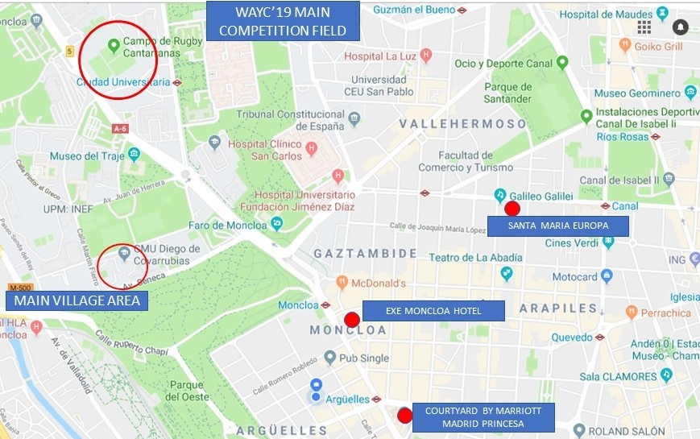
Important Note:
Please refer to the accommodation pages for detailed hotel information.
Please complete all the necessary sections in WAREOS and make full payment for entries, transport and accommodation by the specified deadlines.
Bank transfers only, no credit cards or travel checks will be accepted.
Participants who book their accommodation in non-official hotels will need to pay a double entry fee. In addition, the LOC will not be responsible to provide any event information at this hotel or provide transportation to the venues.

Teams that book non-official accommodation will need to register at the Championships accreditation office no later than the day before official practice day. Failing to do so will result in changes being made to the entry lit and it is likely that participation in the event will be refused if registration is not competed in time.

ENTRY FEE
Entry fees:
Individual: 230 Euros per athlete
Officials: 115 Euros per person
Temporary Upgrade: 30 CHF per accreditation
(for athletes wishing to be a coach temporarily).

Entry fees in NON official hotels:
Individual: 460 Euros per athlete
Officials: 230 Euros per person
There is no entry fee for teams.

PAYMENT CONDITIONS:

All fees should be paid in full before arrival.

Payment of accommodation and local transportation: a minimum deposit of 50% of the total amount owed should be made when booking accommodation by the referred date. The final outstanding balance shall be transferred before arrival. Accommodation cannot be guaranteed after this deadline.
A balance invoice will be provided via WAREOS.

LOC BANK INFORMATION:
(ACCOMMODATION, TRANSPORTATION and ENTRY FEES)

BANK: BANCO SABADELL
ADDRESS: C/ Núñez de Balboa, 20 - 28001 Madrid (Spain)
BANK ACCOUNT HOLDER NAME: Real Federación Española de Tiro Con Arco
ACCOUNT NUMBER: ES64 0081 2341 3100 0101 8811
BIC: BSAB ESBB
SWIFT CODE: BSABESBBXXX

NOTE: All payments shall be made in EUR by BANK TRANSFER.

Bank transfer fees are responsible on the SENDER.
CREDIT CARDS and TRAVEL CHECKS will not be accepted.

ADDITIONAL INFORMATION

TRANSPORT

Transportation will be provided from Madrid airport to the official hotels (fee-based service), while local transport will be available between official hotels, practice and competition venues, starting two days before the official practice day and two days after the closing day.

Transport schedules will be confirmed on site.

Transportation fees from/to the airport:
25,00€ one way
50,00€ way and return

CANCELLATIONS & CHANGES

All cancellations and changes must be made through WAREOS:
- Cancellations received each hotel referred date:
a full refund of the deposit payment will be made.
- Cancellations received after each hotel referred date:
no refund will be given.
- Refunds will be processed after the event.
- Name changes to team officials or athletes (same category and division) will be accepted up to 72 hours before the event without any additional charge.
- Should flight arrival details change last minute, please contact the Organizing Committee using the details indicated in the Team Managers’ Booklet.
- If a participant’s arrival is later than the original scheduled arrival date, the room charges will start from the dates of the original booking made by the Member Association.
- Any changes made in WAREOS an email will automatically be sent to the Organizing Committee and Member Association with the updated information.

TRAINING

Training venues will be available starting from August 16th, 2019.
The Spanish Archery Federation is not able to provide any practice field prior to the championship. Please contact directly the LOC to request earlier practice sessions in the WAYC practice field: wayc2019@federarco.es

INTERNET

Free WIFI will be available in the official hotel (in hotel rooms and in the lobby). There will also be Wi-Fi available for access to results.

WATER

Water will be available at the qualification and practice venues.

MEDIA REGISTRATION

Media representatives can apply for registration by emailing wayc2019@federarco.es

EXPECTED WEATHER IN AUGUST IN MADRID

Average Temperature 25,1 º C
Low Temperature 18,8º C
High Temperature 31,3º C
Sunshine Hours 13 hours
Rainfall days 2 days
Sunrise 7:30
Sunset 21:00

VISA SUPPORT
All participants who need an entry visa to the Spain, will be required to complete the Visa Support Form in WAREOS no later than 17 May 2019.

It is the applicants’ responsibility for supplying the necessary information, ensuring all details are up to date, correct and submitted by the deadlines specified.

In addition, all participants that require a visa are kindly requested to supply a copy of their latest/valid passport. Copies of each applications can be uploaded on WAREOS. All passport copies and personal details entered/uploaded to WAREOS will be held securely and in the strictest of confidence and will not be shared with other parties.

Please note that the Organizing Committee can provide invitation for the period of the Youth World Archery Championships only.

LOC CONTACT
Name: Rifaat Chabouk
Language: English and Spanish

Email: wayc2019@federarco.es
Official website: www.federarco.es/wayc2019

President Organizing Committee: Mr. Vicente Martínez Orga

MADRID
From Madrid to Heaven! It is one of the most popular sayings about the city.
The sky of Madrid has an intense blue colour that makes it characteristic.

It is the Spanish capital since 1561 and it is home to important institutions of the State as it is the central government’s headquarters. Moreover, it is the official residence of the Spanish monarchs and some national bodies, such as the Spanish Royal Academy, and of international bodies like the World Tourism Organization.

The Spanish capital is a cosmopolitan city that combines the most modern infrastructures with its status of economic, financial, administrative and service centre. Madrid has an outstanding transportation network, which makes easier the access by road, airplane, train or metro, and it has one of the best local public transport services in the World.

The Adolfo Suárez Madrid-Barajas airport, which it is the main mean of access to Spain and the main departure and arrival airport to South America, is one of the most important airports in the World regarding the number of passengers.

With a vast artistic and cultural patrimony, heritage of several centuries of a rich and passionate history, Madrid has been witness to the birth of celebrated and universal figures such as Lope de Vega, Calderón de la Barca, Francisco de Quevedo, Jacinto Benavente, Jardiel Poncela, José Ortega y Gasset, Gregorio Marañón, Juan Gris, Juan de Villanueva, Ruperto Chapí, Federico Chueca and Joaquín Rodrigo, among others, and many other intellectuals, artists and other famous celebrities that lived in the city.

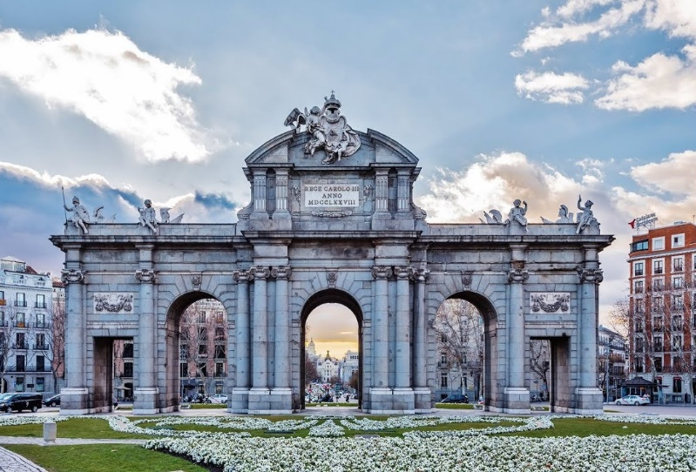
Madrid is an open city for who is willing to discover it, where culture, gastronomic, business, leisure and entertainment activities are blended, being one of the most strong and diverse tourist attraction in Europe and in the World. Probably there is not a city like Madrid with so many things to do and visit being so close to each other.

A PIECE OF LIVING HISTORY: “MADRID DE LOS AUSTRIAS”
(HABSBURG MADRID)

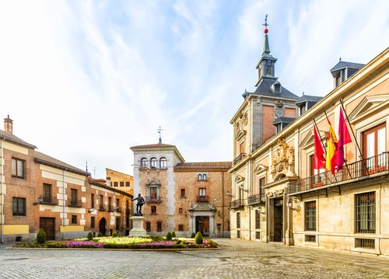
Madrid possesses one of the most important historic centres in Europe, also known as “Madrid de los Austrias” (Habsburg Madrid). It is located around the “Plaza Mayor” (Main square), inaugurated in 1620, and the “Plaza de la Villa” (Village square), which is the old City Hall headquarters.
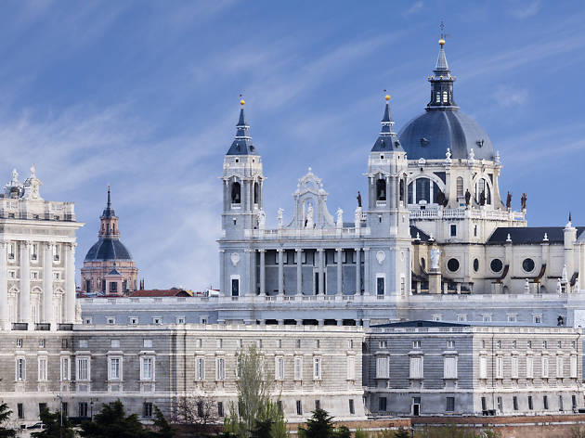
Near “Plaza Mayor” you can take a walk feeling like a king until the so-called “aristocratic centre” of Madrid, where you can discover the beauty of the Royal Palace (“Palacio Real”), the “Plaza de Oriente”, the Opera house or the Almudena Cathedral. This is the Madrid of the Bourbons (“Borbones”).
I would recommend you to visit the “Mercado de San Miguel” (San Michael’s Market) at aperitif time, where it is currently in vogue to have “Tapas”, buy top quality food, or even buy the current bestseller novel.

RECALL THE TWELVE GRAPES

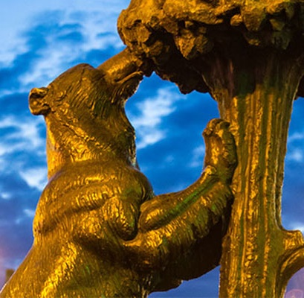
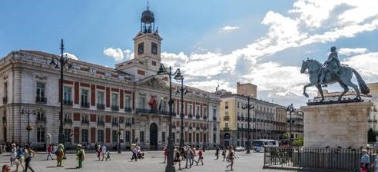
Following the “Calle Mayor” you will find the “Puerta del Sol”, with its “Km 0”, 100 year old shops and the large clock where many Spanish people see the new year in. Take a picture with the bear and the strawberry tree statue (“El oso y el Madroño”), the symbol of the city.
It is about time to do some shopping: from here, and in streets like Preciados or Gran Vía, you will find a large number of stores, department stores and shopping malls where you can find the ultimate technology.

THE BEST MUSEUMS IN THE WORLD

Among this cultural offering, three world’s top art galleries should be highlighted: Prado Museum, Thyssen-Bornemisza Museum and Reina Sofía Museum, forming what is called The Art Walk.
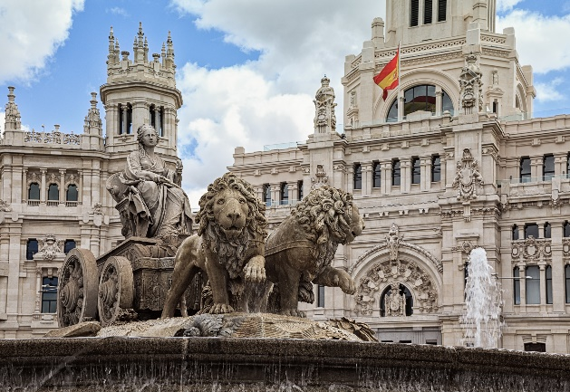
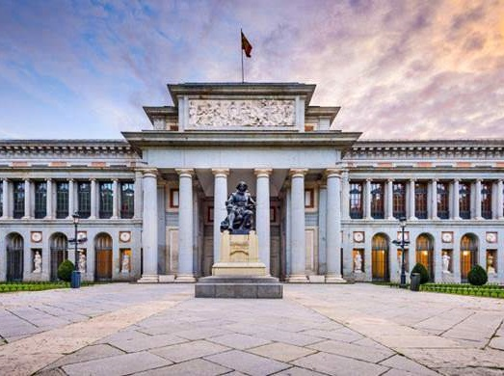

Enjoy a pleasant walk through its gardens and you will be able to contemplate the historic buildings and monuments that shine out with their own light, with Cibeles and Neptuno fountains, the Bank of Spain, the Palace of Communications (the current headquarters of Madrid city council) and the “Puerta de Alcalá”.

STREET CULTURE

The most monumental Madrid is represented by the “Plaza Mayor”, the “Plaza de Oriente”, the National Library, the Royal Palace or the Jerónimos Church. And do not forget the municipalities and surroundings around it.

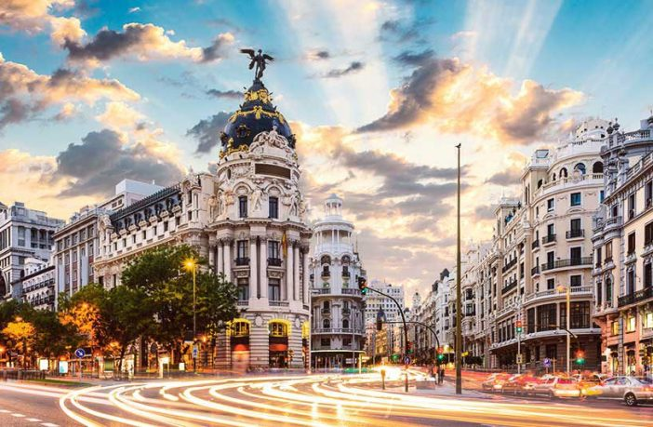
Great cultural centres, such as the “Círculo de Bellas Artes” (Fine Arts Circle), “La casa encendida” (House on fire), Conde Duque Cultural Centre, Caixa Forum or the Casa de América have become the movers and shakers of Madrid’s culture. With fairs like the Book Fair of Madrid, the Contemporary Art Fair (ARCO) or PHotoEspaña, Madrid becomes a national and an international spotlight.
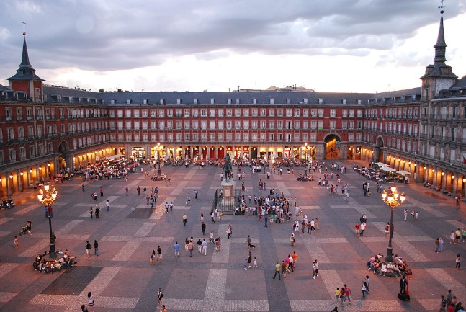

Culture is also felt on the streets of Madrid, a wide range of activities are promoted which surprises both people of Madrid and visitors. There are a lot of spontaneous activities everywhere, contributing to the life of Madrid. For example, the traditional puppet theatre in the Retiro Park, that every weekend delights the younger children. Annually events such as Theatre Night, Museum Night or Book Night, allow all those who wish to do so to enjoy the culture up to early hours.

A TRIBUTE TO THE PALATE

The gastronomy of Madrid is something that you cannot miss either. It is very typical to have “Cocido Madrileño” and “Tapas” in any of the traditional bars, where a stop is required in order to restock on energy and keep on touring the city. Madrid is able to satisfy any demand. It has more than 10,000 restaurants, 40,000 bars and 3,000 cafes. A wide range of establishments represent the best of the Madrid’s cuisine, as well as national and international cuisine due to the strategic positioning of Madrid. According to the most prestigious gastronomic guides, Madrid has the highest recognized quality. This fact makes Madrid the most important city in Europe when it comes to gastronomy and cuisine.
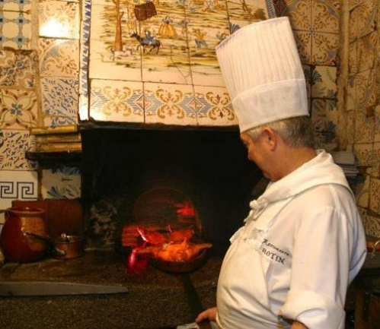
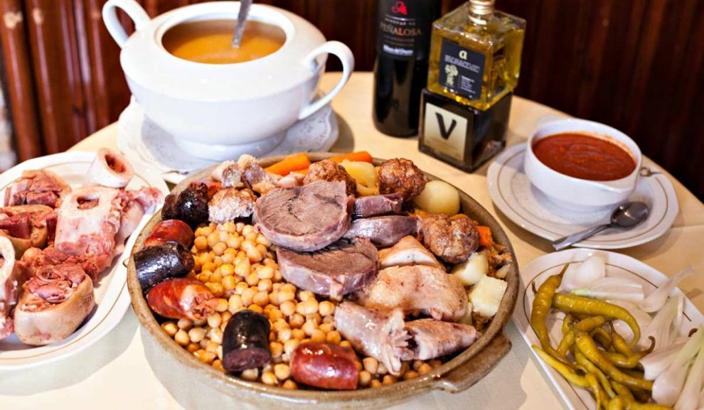
There are many Michelin-starred restaurants, the highest award in this sector, thanks to chefs like David Muñoz (Diverxo), Sergi Arola, Mario Sandoval, Diego Guerrero, Óscar Velasco, Ricardo Sanz, Ramón Freixa, Paco Roncero and Juan Antonio Medina. All of them are international benchmarks of the Spanish creative cuisine, which have made Madrid and our region their refuge.

But if you prefer tradition, you must visit our centenary restaurants, such as the Taberna Malacatín, Casa Ciriaco, La Bola, Botín, Casa Labra, el Café Gijón or Lhardy. There, history and culture of Madrid come together with the pleasure of a great dish, the best way to finish a night in Madrid.

As a curious fact, Madrid hosts the oldest restaurant in the World: Casa Botín.

TAPAS AND EVENTS

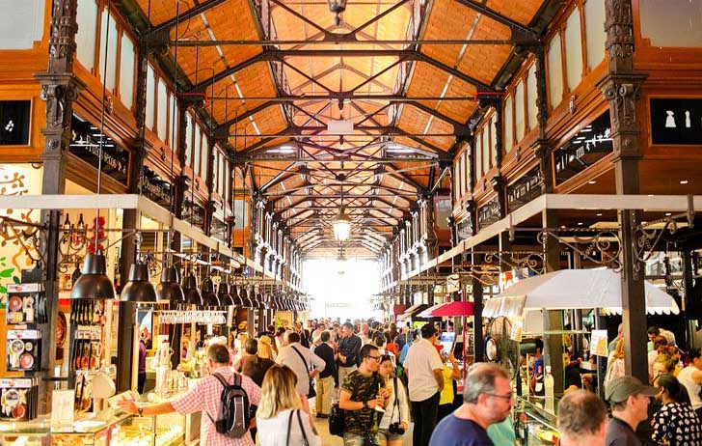
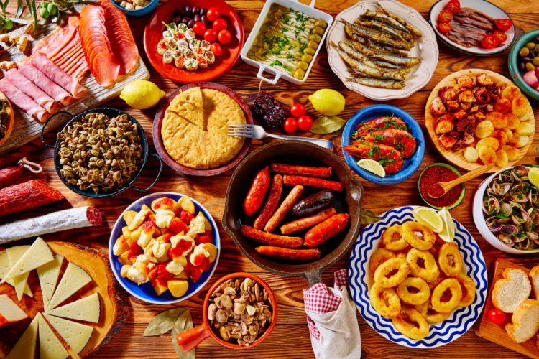
If you are an impassionate gourmet, there are many events and performances related to haute cuisine celebrated in Madrid that you can’t afford to miss. Events like Madrid Wines Show, Millésime, the Gourmet Club International Exhibition or the important “Madrid Fusión” Gastronomic Summit, make Madrid the Gastronomy Capital of the World.
There are a lot of areas around the capital where you can taste the best gastronomy of our bars and restaurants. In the Central Area you can have the traditional squid baguette or try tap vermouth and centenary restaurants. La Latina neighbourhood hosts typical and classic taverns, and especially on weekends it becomes one of the most dynamic areas of the capital, as well as Huertas, the Cava Baja and the Plaza de Santa Ana (Santa Ana square). The traditional Chamberí neighbourhood, the gourmet markets like San Miguel, San Antón or San Ildefonso Markets and Platea Madrid are dedicated to national and international gastronomy. In Platea Madrid you will find restaurants, cocktail bars, pastry shops, stores and shows, and it is one of the biggest gastronomic areas in Europe and the most interesting in the World, with 6000 square meters, six Michelin stars and eleven Repsol suns.

GO SHOPPING

Before coming back home you can go shopping. Madrid is the second shopping destination in Europe and one of the most important in the World. You will find pretty much everything you can imagine due to its big and diverse shopping areas.

The famous “Milla de Oro” (Golden Mile) in the Salamanca neighbourhood, is a tourist mandatory visit for luxury shopping. The greatest Spanish fashion firms like Loewe, Amaya Arzuaga, Kina Fernández, Adolfo Dominguez, Ágatha Ruiz de la Prada, Roberto Verino, Manolo Blahnik or Angel Schlesser go hand in hand with international luxury icons such as Chanel, Armani and Valentino. The jewelleries, shoe shops and the most prestigious fashion and complements, as well as art galleries and antique shops make this shopping offering complete. Going shopping around the boutiques and shops in Salamanca neighbourhood is a pleasure for the most elite pockets.

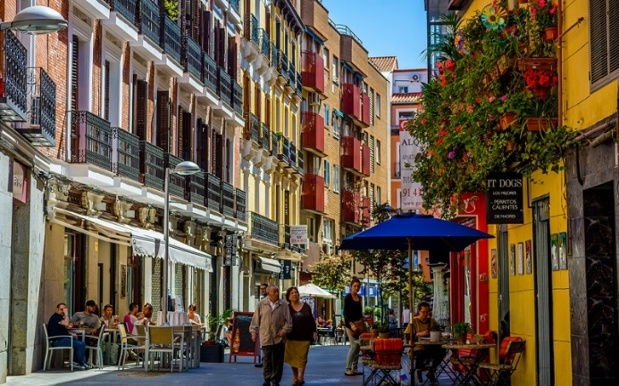
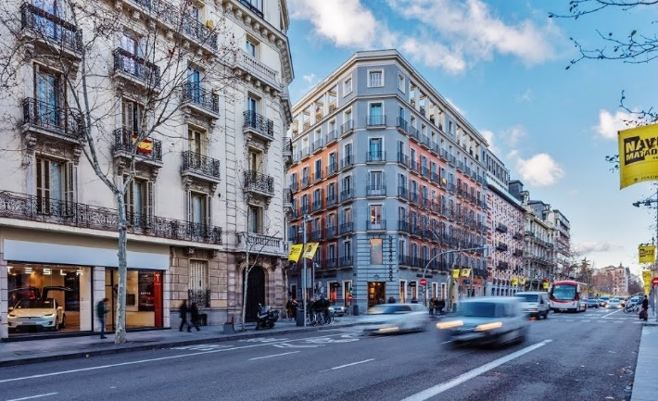
In the central area of the capital you will discover the most traditional products. Craftsmanship, ceramics, metalwork, leather products, hand fans, guitars, Manila shawls, typical “chulapo” caps and the famous espadrilles among others, complement the shopping offers of small shops with centuries of history, as active as on the first opening day.

If you are looking for original, avant-garde, bohemian and the latest fashion trends, you should definitely visit Chueca and Fuencarral. You will find there many small shops for young and transgressor people. The area is framed within the Triball Madrid project, an important commercial and touristic focal point similar to New York’s Soho. One of its main exponents is Fuencarral Market (“Mercado de Fuencarral”), where craftspeople, designers and small traders all around Spain offer different products that are so original that are very difficult to find anywhere else.

If you travel with your family, you can visit any of our shopping malls. Madrid has many of them, and there you can find everything you need: you can have refreshment, have a snack, watch a movie or bowling. You will enjoy a funny and amazing shopping time.

If you want to find small treasures, El Rastro of Madrid is your place. It occupies a great extension of streets between Lavapiés and La Latina, with Cascorro Square as the reference centre. It is only open on Sundays and public holidays from dawn to lunch time. Dig through objects, books, CDs, antiques and collectibles. Later on, you can have an appetizer inside some of the traditional taverns or you can taste creative tapas in one of the fashion establishments. However, El Rastro is not the only flea market and there are many of them all around the city in public places and on determined days. The products for sale are varied: food, clothes, household goods, plants, jewellery, etc. They have always had great public acceptance, since the markets have in the same place a wide variety of items and they have lower prices than traditional shops.

For more information, please visit the official website of the Madrid tourism board http://turismomadrid.es/en/

