TO ALL World Archery MEMBER ASSOCIATIONS

Dear President,

On behalf of the Local Organising Committee of the World Archery Youth Championships 2017, and World Archery Argentina (FATARCO); I would like to invite you to the World Archery Youth Championships 2017, 2 – 8 October in Rosario, Argentina.

Please find enclosed the necessary information for registration, organisation and participation for this event. Please complete all the necessary details in WAREOS before the following deadlines:

Summary of deadlines:

- Preliminary Entries 04 July 2017
- Final Entries 11 September 2017
- Hotel Reservation 04 July 2017
- Transportation 04 July 2017
- Visa Support 04 July 2017
- Final Hotel Reservation & Payment 11 September 2017

Looking forward to welcoming you in Rosario, Argentina.

Sincerely yours,

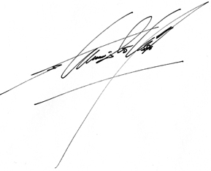

Mr Estanislao Osores Soler
President
Organising Committee

PRELIMINARY PROGRAMME

30 September 2017 | Arrival of participants  Practice field and local transport available
1 October 2017  Sunday | Arrival of participants  Practice field and local transport available
02 October 2017  Monday | Official Practice and Opening Ceremony  Equipment Inspection  Team Managers Meeting
03 October 2017  Tuesday | Qualification Round Recurve and Compound  (Junior Recurve 70m and Compound 50m Round)  (Cadet Recurve 60m and Cadet Compound 50m Round)  Shoot offs if required
04 October 2017  Wednesday | Individual Eliminations  (Junior Recurve 70m and Compound 50m Round)  (Cadet Recurve 60m and Cadet Compound 50m Round)
05 October 2017  Thursday | Individual Eliminations and Mixed Team  (Junior Recurve 70m and Compound 50m Round)  (Cadet Recurve 60m and Cadet Compound 50m Round)
06 October 2017  Friday | Team Eliminations &  2018 Youth Olympic Games Qualifier Tournament
07 October 2017  Saturday | Finals – Compound
08 October 2017  Sunday | Finals – Recurve  Closing Ceremony and Party
09 October 2017  Monday | Departure of teams

NOTE:
This is a preliminary program and could be changed according to the number of participants and TV requirements. All changes will be published and distributed to all participants in good time.

PRELIMINARY & FINAL REGISTRATION

All entries, accommodation reservations, transport needs, flight arrival/departure information and visa invitation letter requests are to be completed using WAREOS.

The World Archery Online Registration System (WAREOS): http://register.worldarchery.org has been updated to handle the entire registration process for this event. No entry forms, hotel reservations or transport forms will be accepted as all information is to be entered into WAREOS.

In order to use WAREOS, please login on http://register.worldarchery.org with your Username and Password assigned by World Archery. After entering WAREOS, please find the event, from the list, for which you wish to register your athletes. Select/press the “Entries” button to see the list of categories in the event. Select/press the “category” to enter the athlete and official numbers/details participating for that event. A "WAREOS User Manual" can be downloaded in PDF format (English) using the same website link.

For any questions regarding the WAREOS, please contact the World Archery office, Mr. JK LEE (jklee@archery.org).

A maximum number of 3 athletes per country is allowed to be registered into each category of the event. Preliminary entries should be completed using WAREOS.

Start date for online registration using WAREOS 19 April 2017
End of Preliminary registration using WAREOS: 04 July2017
End of Final registration using WAREOS: 11 September 2017

Please respect the stated deadlines.

Member Associations should only use WAREOS to make any changes/amendments to their entries and will be able to do so at any time. Any changes made in WAREOS an email will instantly be automatically sent to the Organising Committee and Member Association with the updated information.

However, for any changes made after the deadlines specified or if entries differ by more than 4 athletes from the preliminary entries, the following penalty fees will automatically be applied.

Penalty fees to be paid to Organising Committee: | Cost (USD):
Entries made after the preliminary and/or final entry deadline date. | 50 per entry
If final entries differ from the preliminary entries by more than 4 athletes/officials. | 150 per entry
Failure to have made preliminary entries before the deadline date but then submitting final entries. | 150 per entry

Penalty Fee to be paid to World Archery: | Cost (USD):
Lost accreditation. | 30 each
Changes made to the athlete and/or team official names after the final entry deadline date and within 3 days prior to the start of the event. | 50 each change

NOTE: USD currency exchange rates will be those on the date of the event.

Member Associations that have penalty fees outstanding from 2016 must pay these penalty fees before being eligible to enter and compete.

Any entries received less than 3 days before the team managers meeting for the World Championships will be refused if no preliminary entry and/or final entry are made prior. This decision cannot be appealed by the teams and is fully compliant with the current World Archery rules, article 3.7.1.2. Entries received after the deadlines are subject to penalties as clearly stated in the rule book and the invitation documents of World Cups and World Championships. A Member Association that has made final entries in WAREOS and does not participate will be invoiced for the number of entries entered in the system, unless they have informed World Archery and the Organising Committee in writing at least one week prior to the event that they are unable to attend.

ACCOMMODATION & GENERAL INFORMATION
The official hotels are the Pullman and the Holiday Inn. Hotel allocation will be made on a “first come, first serve basis”. Accommodation rates include breakfast, lunch and dinner buffet with non-alcoholic drinks.

Lunch will be served at the Jockey Club near the premises used for the qualification rounds.

Teams that book their own accommodation in hotels not arranged by the Organising Committee will be charged a double entry fee.
- Reservations should be made before: 04 July 2017
- Final Hotel Reservation & Transportation before: 11 September 2017.

To confirm hotel reservations, 50% of the total amount deposit is to be paid by a bank transferred to the OC before 04 July 2017. Reservations after this date will be considered only according to availability.

1. - PULLMAN HOTEL (five stars)

- Single room USD 200/per person/day (full board)
- Double/Twin room USD 150/per person/day (full board)
- Triple room USD 120/per person/day (full board)

BANK INFORMATION for PULLMAN HOTEL ACCOMODATION ONLY

Standard Chartered Bank, New York, USA
One Madison Ave., New York, NY 10010-3603, USA
Swift code SCBNUS33
ABA 026002561
Beneficiary: Banco Macro S.A., Buenos Aires, Argentina
Ac. 3544032487001
Swift code BOSUARBA
For further credit to CASINO DE ROSARIO S.A.
Ac. 367209405667663

http://www.citycenter-rosario.com.ar

PULLMAN HOTEL (five stars)
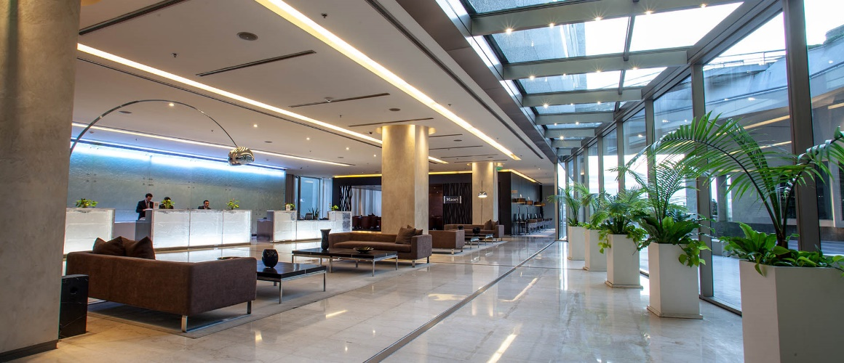
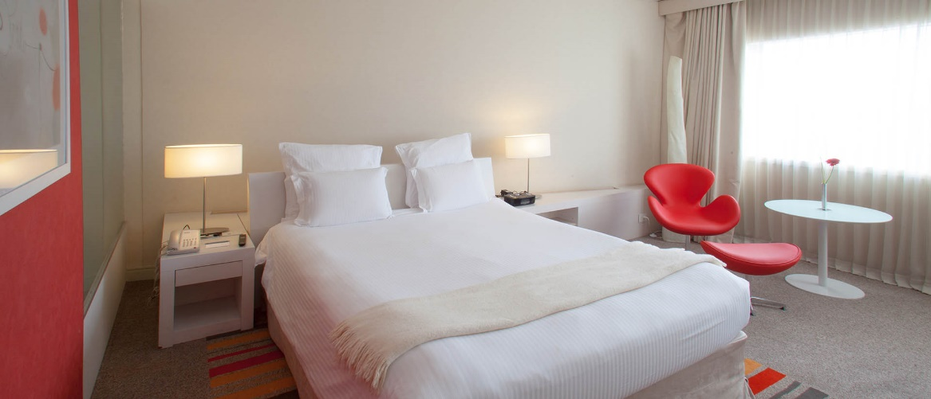

2. - HOLIDAY INN HOTEL (four stars)
- Single room USD 200/per person/day (full board)
- Double/Twin room USD 150/per person/day (full board)
- Triple room USD 120/per person/day (full board)

BANK INFORMATION for HOLIDAY INN HOTEL ACCOMODATION ONLY
Standard Chartered Bank, New York, USA
One Madison Ave., New York, NY 10010-3603, USA

Swift code SCBNUS33
ABA 026002561
Beneficiary: Banco de Galicia, Buenos Aires, Argentina
Ac. 3544032000001
Swift code GABAARBA
For further credit to ORGANIZACION PANAMERICA S.A.
Ac. 975010312336

http://www.holidayinnrosario.com

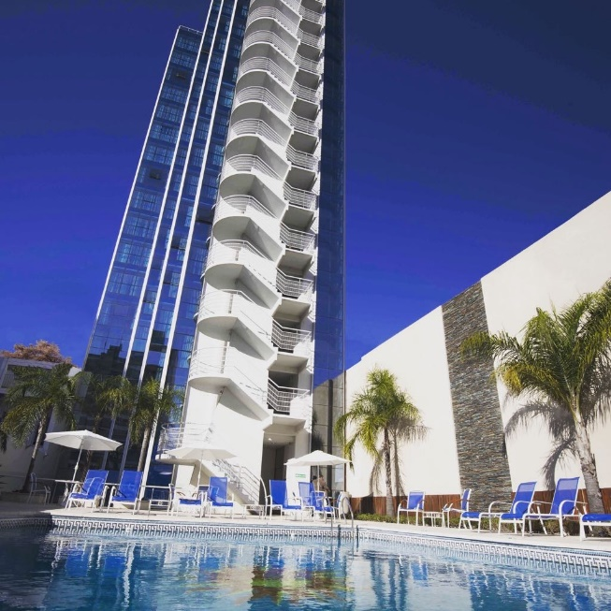
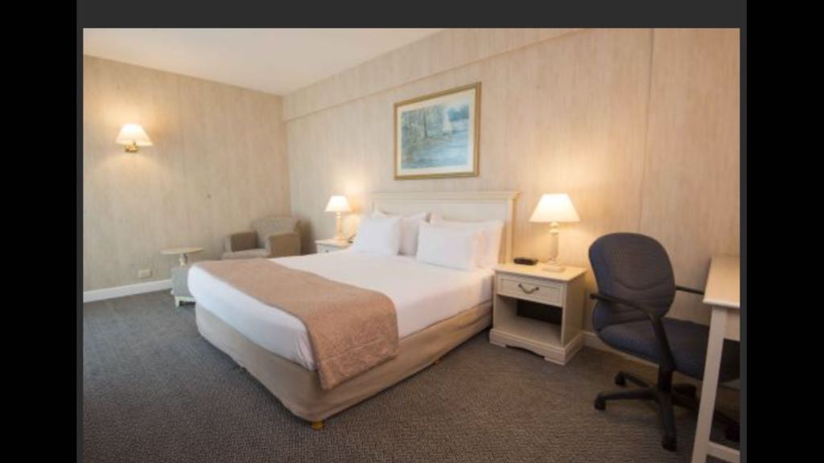

Important Note:

Please refer to the accommodation pages for detailed hotel information. Please complete all necessary sections in WAREOS and make full payment for entries and accommodation by the specified deadlines. Bank transfers only, no credit cards or travel checks will be accepted.

Participants who book their accommodation in non-official hotels will need to pay a double entry fee. In addition, the LOC will not be responsible to provide any event information at this hotel or provide transportation to the venues.

Teams that book non-official accommodation will need to register at the Championships accreditation office no later than the day before official practice day. Failing to do so will result in no changes being made to the entry list and it is likely that participation in the event will be refused if registration is not completed in time.

ENTRY FEE
Entry Fees:
Individual: | 200 USD per athlete
Officials: | 100 USD per person
Temporary Upgrade: | 30 USD per accreditation (for athletes wishing to be a coach temporarily)
Entry fee in NON official hotels:

Individual: 400 USD per athlete
Officials: 200 USD per person

No entry fee for teams.

Entry fees include daily local transport to and from the practice field to/from official hotels during the qualification, elimination and final rounds (schedule to be confirmed on site).
Entry fees do not include bus transportation from international Ezeiza or Aeroparque airports in Buenos Aires to Rosario, and from there to official or non-official hotels. Nor do they include transportation to the non-official training field before September 30 or the cost of the use of such a field.

AIRPORT TRANSPORTATION FEES

Tienda León bus from Buenos Aires Ezeiza or Aeroparque airports:
USD 140/person/round trip. It includes free of charge transportation of one handbag, one suitcase and one bow case per person. Drop off at the official hotels. This rate/service is only valid for Tienda León bus service requested via WAREOS.
Transportation between Rosario airports and the official hotels is free of charge.

PAYMENT CONDITIONS:
Entry fees should be paid in full before arrival.

Payment of accommodation and local transportation: a minimum deposit of 50% of the total amount should be made when booking by 04 July 2017. The final outstanding balance shall be transferred before arrival. Accommodation cannot be guaranteed after this deadline. A balanced invoice will be provided via WAREOS.

BANK INFORMATION TO BE USED for TRANSPORTATION and ENTRY FEES ONLY

BANK: STANDARD CHARTERED BANK, New York, USA
ADDRESS: One Madison Ave., New York, NY 10010-3603, USA
ABA 026002561

SWIFT CODE: SCBLUS33XXX
CHIPS UID 011575, 404782
ACCOUNT: 3544034620001 Banco Santander Rio S.A.
BENEFICIARY BANK SWIFT CODE: BSCHARBA
BANK ACCOUNT HOLDER NAME: FATARCO
ACCOUNT 024-18176/3

NOTE: ALL PAYMENTS SHALL BE MADE IN USD By BANK TRANSFER.

All bank charges will be paid by the participants.
CREDIT CARDS or TRAVEL CHECKS will not be accepted.

ADDITIONAL INFORMATION
Transportation
Transportation will be provided from Rosario airport to the official hotels, two days before the official practice day and two days after the closing day. Local transport will be available between official hotels, practice and competition venues. Transport schedules will be confirmed on site. Buses and/or vans will be provided.

Cancellations & Changes
All cancellations and changes must be made through WAREOS:
- Cancellations received before 21 August 2017 a full refund of the deposit payment will be made.
- Cancellations received after 21 August 2017, no refund will be given.
- Refunds will be processed after the event.
- Name changes to team officials or athletes (same category and division) will be accepted up to 72 hours before the event without any additional charge.
- Should flight arrival details change last minute, please contact the Organising Committee using the details indicated in the Team Managers’ Booklet.
- If a participant’s arrival is later than the original scheduled arrival date, the room charges will start from the dates of the original booking made by the Member Association.
- Any changes made in WAREOS an email will automatically be sent to the Organising Committee and Member Association with the updated information.

Training
A non-official training field will be available as from 27 September 2017. The training field is near the competition field and around 10 km from the hotels.
Transportation and use of facilities should be arranged by each team at their own cost)

For those teams competing in the 2017 Hyundai World Championships in Mexico City, 2 weeks later, please contact the LOC if your team wishes to stay in Rosario to practice before travelling onto Mexico City.

Weather
According to weather information, the average temperature in October is expected to be around 16-24 °C.

Media Registration:
Media representatives can apply for registration by emailing info@archery.org

Ceremonies
Opening or closing ceremony as per preliminary programme.

Internet
Will be available in the official hotels for free (in hotel rooms and in the lobby). There will also be Wi-Fi available for access to results

Water
Bottled water will be available at the qualification and practice venues

LOC Contact:
Name: Estanislao OSORES SOLER (President)
María Luisa GIACOMUCCI (CEO)
Language: English and Spanish
Email: fatarco.waargentina@gmail.com
Official website: http://wayc2017rosario.com.ar
General Mail: loc.rosario2017@wayc2017rosario.com.ar

Transport and Hotels
María Giacomucci: hotels@wayc2017rosario.com.ar

Competition Manager
Sergio Font: competitionmanager@wayc2017rosario.com.ar

Treasury
Olga Traferro: treasury@wayc2017rosario.com.ar

Visa
All participants who need an entry visa to Argentina, will be required to complete the Visa Support sections in WAREOS by no later than 07 August 2017.

It is the applicants’ responsibility for supplying the necessary information, ensuring all details are up to date, correct and submitted by the deadlines specified.

In addition, all participants that require a visa are kindly requested to supply a copy of their latest/valid passport. Copies of each applicate can be uploaded on WAREOS. All passport copies and personal details entered/uploaded to WAREOS will be held securely and in the strictest of confidence and not shared with other parties.

