

**Para Archery**

**World Championships**

**Invitation Package**

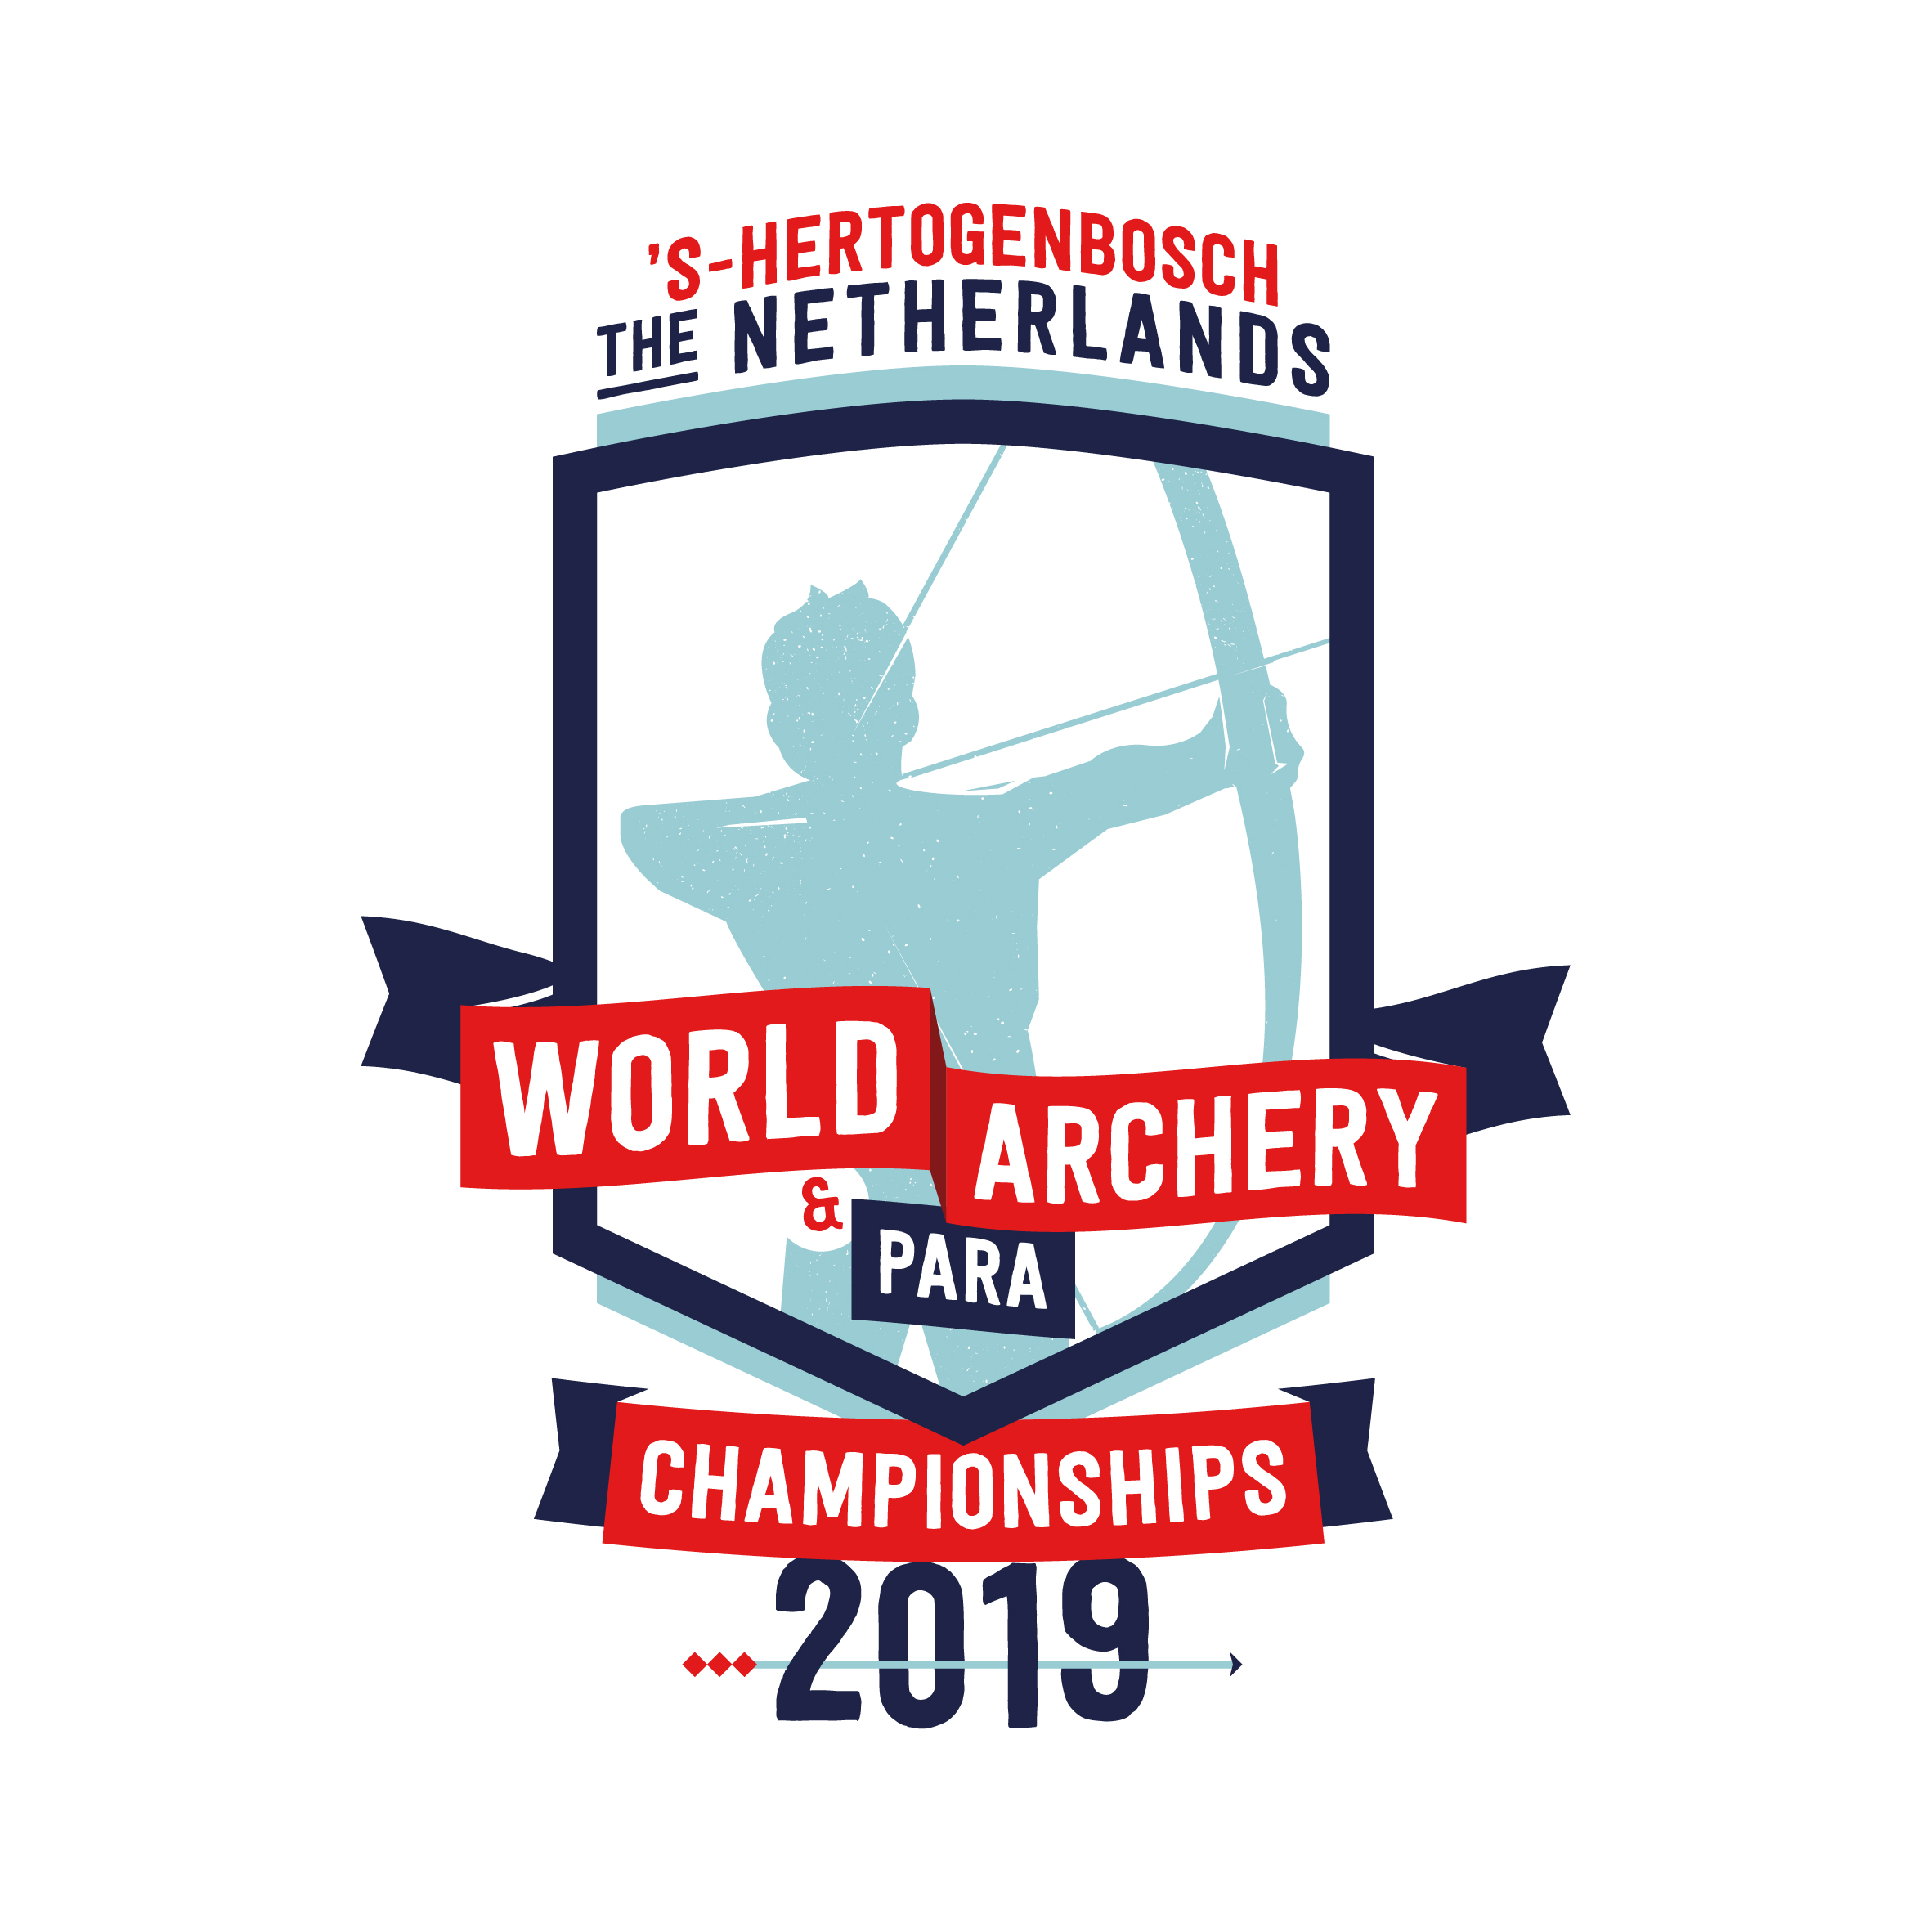

**TO ALL World Archery MEMBER ASSOCIATIONS**

Dear President,

On behalf of the Local Organizing Committee (LOC) of the World Archery Para Championships 2019, ‘s-Hertogenbosch – Netherlands, we would like to invite your country to the World Archery Para Championships 2019, which will be held from 2 to 9 June in ‘s-Hertogenbosch – Netherlands.

Please find enclosed the necessary information for registration, organization and participation for this event. Please complete all the necessary details in WAREOS before the following deadlines:

Summary of deadlines:

* Preliminary Entries 4 March 2019
* Final Entries 10 May 2019
* Hotel Reservation 8 February 2019
* Transportation 30 April 2019
* Visa Support 1 April 2019
* Medical intake and classification forms for 3 May 2019

VI and Physical Impairments completed in

English sent to e-mail:

[classification@archery.org](mailto:classification@archery.org)

* Final Hotel Reservation 1 April 2019

& Payment

We will host the 2019 World Archery Congress (1 – 2 June) and the 2019 World Archery Championships (09 - 16 June) prior to and after the World Archery Para Championships. A separate invitation package will be available to our Member Associations to register their attendance to both events.

Please note that accreditation for the World Archery Congress is not valid as accreditation for the Championships, as a separate team official registration is required for the event. For ticket information please check our website.

We are looking forward to welcoming you and your teams, to ‘s-Hertogenbosch – The Netherlands!

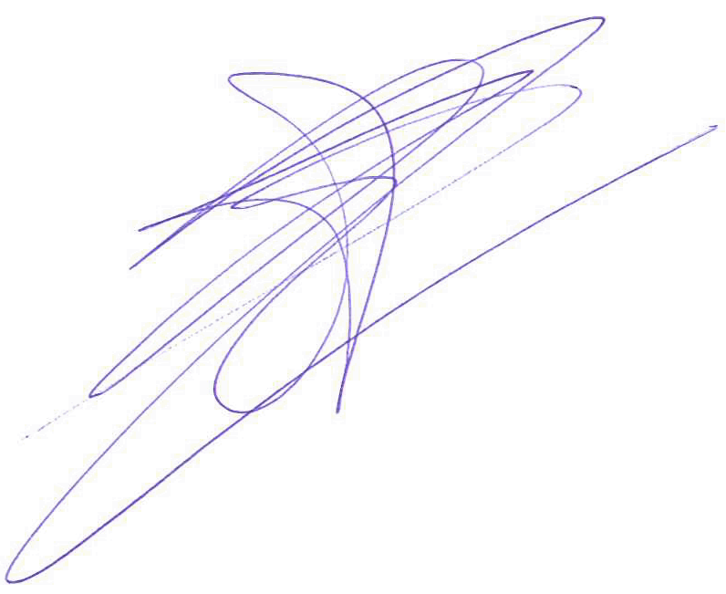Sincerely yours,

Mr. Eric Kersten

President Organizing Committee

PRELIMINARY PROGRAMME

|  |  |  |  |  |
| --- | --- | --- | --- | --- |
| **Day** | | | **Date** | **Description** |
| Day -2 | Friday  31 May | | | Arrival of participants  Practice field and local transport available |
| DAY -1 | Saturday  1 June | | | Arrival of Participants  Practice field and local transport available |
| DAY 0 | Sunday  2 June | | | Official Practice V1, W1 (Women and Men)  Official Practice Compound (Women and Men)  Official Practice Recurve (Women and Men)  Registration and Equipment Inspection  Team Managers Meeting  Opening of the Championships |
| DAY 1 | Monday  3 June | | | Qualification Round |
| DAY 2 | Tuesday  4 June | | | Qualification Round  Team and Mixed Team Eliminations  VI Eliminations and Finals |
| DAY 3 | Wednesday  5 June | | | Mixed Team and Individual Eliminations   * Recurve (Women, Men and Mixed Teams) * Compound & W1 (Women, Men and Mixed Teams) |
| DAY 4 | Thursday  6 June | | | Individual and Mixed Team Elimination   * Recurve, W1 & Compound (Women and Men) |
| DAY 5 | Friday  7 June | | | Paralympic Secondary Qualification Tournament for Tokyo 2020 |
| DAY 6 | Saturday  8 June | | | Finals Compound & W1   * Team Medal Matches * Mixed Team Medal Matches * Individual Medal Matches * Awards Ceremony |
| DAY 7 | Sunday  9 June | | | Finals Recurve   * Team Medal Matches * Mixed Team Medal Matches * Individual Medal Matches * Awards and Closing Ceremony |
| DAY 8 | | Monday  10 June | | Departure of teams |

**NOTE:** This preliminary programme could be changed slightly according to number of participants and TV requirements. All changes will be published and distributed to all participants in good time.

PRELIMINARY & FINAL REGISTRATION

All entries, accommodation reservations, transport needs, flight arrival/departure information and visa invitation letter requests are to be completed using WAREOS.

The World Archery Online Registration System (WAREOS): <http://extranet.worldarchery.org> has been updated to handle the entire registration process for this event. No entry forms, hotel reservations or transport forms will be accepted as all information is to be entered into to WAREOS.

In order to use WAREOS, please login on <http://extranet.worldarchery.org> with your Username and Password assigned by World Archery. After entering WAREOS, please go to "Online Registration" and register your athletes and officials for this event. A "WAREOS User Manual" can be downloaded in PDF format (English) using the same website link.

For any questions regarding WAREOS, please contact the World Archery office, Mr. JK LEE ([jklee@archery.org](mailto:jklee@archery.org)).

A maximum number of **3 athletes per country** is allowed to be registered into each category of the event. Preliminary entries should be completed using WAREOS.

Start date for online registration using WAREOS **15 November 2018**

End of Preliminary registration using WAREOS: **4 March 2019**

End of Final registration using WAREOS: **10 May 2019**

Please respect the stated deadlines.

Member Associations should only use WAREOS to make any changes/amendments to their entries and will be able to do so at any time. After any changes made in WAREOS an email will instantly be automatically sent to the Local Organizing Committee and Member Association with the updated information.

However, any changes that are made after the deadlines specified or if entries differ by more than 4 athletes from the preliminary entries, the following penalty fees will automatically be applied.

|  |  |
| --- | --- |
| **Penalty fees to be paid to Organizing Committee:** | **Cost (EUR):** |
| Entries made after the entry deadline date. | **45** per entry |
| If final entries differ from the preliminary entries by more than 4 athletes/officials. | **140** per entry |
| When no preliminary entries were made before the deadline date but then submit final entries. | **140** per entry |

|  |  |
| --- | --- |
| **Penalty Fee to be paid to World Archery:** | **Cost (CHF):** |
| Lost accreditation. | **30** each |
| Changes made to the athlete and/or team official names after the final entry deadline date and within 3 days prior to the start of the event. | **50** each change |

**NOTE:** CHF currency exchange rates will be those on the date of the event.

Member Associations that have penalty fees outstanding from earlier events will need to have paid these penalty fees before being eligible to enter and compete.

Any entries received less than 3 days before the team managers meeting for a Hyundai Archery World Cup or World Championships will be refused if no preliminary entry and/or final entry are made prior. This decision cannot be appealed by the teams and is fully compliant with the current World Archery rules, article 3.7.1.2. Entries received after the deadlines, are subject to penalties as clearly stated in the rule book and the invitation documents of World Cups and World Championships. A Member Association that has made final entries in WAREOS and does not participate will be invoiced for the number of entries entered in the system, unless they have informed World Archery and the OC in writing at least one week prior to the event that they are unable to attend

**NOTE**: for hotel bookings and transportation a different cancellation policy applies.

More details are to be found on page 11

ACCOMMODATION & GENERAL INFORMATION

The official hotel is Hotel NH Conference Centre Koningshof. Hotel allocations will be made on a “first come, first serve” basis.

Teams that book their own accommodation in hotels not arranged by the LOC will be charged a double entry fee.

* Reservations should be made before **8 February 2019**
* Final Hotel Reservation & Transportation: **1 April 2019**.

To confirm your hotel reservations, a 60% deposit, of the total amount, has to be paid by a bank transfer to the LOC before **8 February 2019.** Reservations received after this date will be considered only according to availability.

1. Hotel NH Conference Centre Koningshof (4 Star)

Single Room 189 EURO*

Double/Twin Room 159 EURO*

The hotel room rates are **per person, per night** and including free internet, full board (breakfast and dinner at the official hotel, lunch at the venue). Dinner is including one nonalcoholic drink. Additional purchases in the hotel bar, café and mini bar is at own expense. * prices are excluding city tax.

One limited edition event gadget per person is included.

All teams that book their accommodation package through the LOC receive

* one parking ticket per country for the St.-Jans parking garage (located under the training venue, Hekellaan 25, ‘s-Hertogenbosch, the maximum clearance in the parking garage is 2.10 meters)
* transport to and from the venue to and from the official hotel during the qualification, elimination and final days is included. (Timetable to be confirmed on site)
* Free use of training lanes, situated at NH Conference Center Koningshof

Classification will be done at the Official Hotel. Parking at Hotel NH Conference Centre Koningshof is free of charge.

During the event there is a tournament desk available in the official hotel with all the relevant and latest information about the World Archery Para Championships.

Hotel NH Conference Centre Koningshof

[**NH Conference Centre Koningshof**](https://www.nh-hotels.com/hotel/nh-eindhoven-conference-centre-koningshof?_ga=2.131400847.1868255884.1493715733-993812478.1493712460) is situated in an area of natural beauty. The biggest congress hotel of the Benelux is situated in the beautiful surroundings of the ‘Brabantse Kempen’ which creates a different atmosphere every season. Upon arrival you will immediately encounter the famous Brabant hospitality.

NH Conference Centre Koningshof offers 509 luxury rooms. The rooms are all situated in a quiet environment and overlook the forest or the patio gardens of the hotel. The hotel room offers free coffee and tea facilities. In the room there is a safe deposit box, wake up service and a mini bar.

Especially for all the participant of the 2019 Para World Archery Championships there will be created adapted shower and toilet facilities in a separate hall of the official hotel. As well as some practice lanes next to the official hotel for the teams to use.

NH Conference Centre Koningshof is ensuring that guests can relax as if they are at home. Relax in one of the bars or use the sport facilities. There is free Wi-Fi in the entire hotel. NH Conference Centre Koningshof will ensure that you have an unforgettable stay.

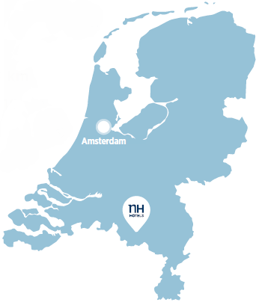Eindhoven Airport 9 km

Amsterdam Schiphol Airport 137 km

Brussels Airport 115 km

Düsseldorf Airport 118 km

Central train station Eindhoven 10 km

Bus stop 0 km (on hotel grounds)

Important Note:

Please refer to the accommodation pages for detailed hotel information. Please complete all the necessary sections in WAREOS and make full payment for entries, transport and accommodation by the specified deadlines. Bank transfers only, no credit cards or travel checks will be accepted.

Participants who book their accommodation in non-official hotels will need to pay a double entry fee. In addition, the LOC will not be responsible to provide any event information at this hotel or provide transportation to the venues.

Teams that book non-official accommodation will need to register at the Championships accreditation office no later than the day before official practice day. Failing to do so will result in changes being made to the entry list and it is likely that participation in the event will be refused if registration is not competed in time.

ENTRY FEE

Entry fee:

Individual: **230 Euros** per athlete

Officials: **115 Euros** per person

Temporary Upgrade: **30 CHF** per accreditation (for athletes wishing to be a coach temporarily).

Entry fee in NON official hotels:

Individual: **460 Euros** per athlete

Officials: **230 Euros** per person

There is no entry fee for teams.

PAYMENT CONDITIONS:

The entry fees should be paid in full upon arrival.

Payment of accommodation and local transportation: a minimum deposit of 60% of the total amount owed should be made when booking by **8 February 2019.** The final outstanding balance shall be transferred before arrival. Accommodation cannot be guaranteed after this deadline. A balance invoice will be provided via WAREOS.

BANK INFORMATION for ACCOMMODATION, TRANSPORTATION and

ENTRY FEES:

BANK: RABOBANK Oss Bernheze

ADDRESS: Postbus 20, 5384 ZG Heesch

BANK ACCOUNT HOLDER NAME: The Event Connection B.V.

ACCOUNT NO: NL83 RABO 0125 5232 54

BIC/SWIFT CODE: RABONL2U

**NOTE**: All payments shall be made in EUR by BANK TRANSFER.

Bank transfer fees are responsible on the SENDER.

CREDIT CARDS and TRAVEL CHECKS will not be accepted.

ADDITIONAL INFORMATION

**Transport**

Traffic between Amsterdam Schiphol airport and s-Hertogenbosch is frequently busy. Therefore, the most efficient and effective way to travel is by train.

**Public transport**

Train from Amsterdam Schiphol airport to the Central station of ‘s-Hertogenbosch. One-way ticket will cost around € 18,- (2nd class ticket), around € 28,- (1st class ticket).

If you travel with a physical disability and need help boarding, transferring, or exiting the train, or if you need someone to guide you through the station, then you can take advantage of the free NS Travel Assistance service. This must be reserved by phone at least one hour before departure: +31 30 235 7822

Volunteers from the organizing committee will be at Schiphol airport to meet, greet and provide assistance in purchasing a train ticket, guide you to the correct platform for the train to ‘s-Hertogenbosch and help with requesting NS Travel Assistence.

Upon arrival at ‘s-Hertogenbosch central train station, you will be met again by volunteers from the organising committee who will assist you with transport to the hotel. There are taxi’s available at ‘s-Hertogenbosch central station to travel from the railway station to your hotel. Payment can be done cash or by card. For more information about traveling by train, check the website [www.ns.nl/en](http://www.ns.nl/en).

Airport transfer

Alternatively, you can reserve a dedicated pick up and drop off (round trip) service from and to the airport with our travel partner, Arriva. Bookings can be made in WAREOS. For teams with athletes bound to their wheelchair the 20 and 50 persons bus can be rebuild. Please make a note by booking your transfer how many athletes are bound to their wheelchairs.

**Amsterdam Schiphol Airport – NH Koningshof\***

|  |  |  |
| --- | --- | --- |
|  | One-way | Retour |
| Taxi (max 3 persons) | € 345,- | € 690,- |
| 9 persons van | € 406,- | € 811,- |
| 20 persons bus | € 436,- | € 872,- |
| 50 persons bus | € 478,- | € 956,- |

**Eindhoven Airport – NH Koningshof\***

|  |  |  |
| --- | --- | --- |
|  | One-way | Retour |
| Taxi (max 3 persons) | € 194,- | € 388,- |
| 9 persons van | € 357,- | € 714,- |
| 20 persons bus | € 406,- | € 811,- |
| 50 persons bus | € 436,- | € 872,- |

*\* prices are per taxi/van/bus*

Cancellations & Changes

All cancellations and changes must be made through WAREOS:

* Cancellations received **before 08/02/2019 (February 8, 2019)** a full refund of the deposit payment will be made.
* Cancellations received **after 08/02/2019 (February 8, 2019)**, no refund will be given.
* Refunds will be processed after the event.
* Name changes to team officials or athletes (same category and division) will be accepted up to **72 hours before** the event without any additional charge.
* Should flight arrival details change last minute, please contact the Organizing Committee using the details indicated in the Team Managers’ Booklet.
* If a participant’s arrival is later than the original scheduled arrival date, the room charges will start from the dates of the original booking made by the Member Association.
* Any changes made in WAREOS an email will automatically be sent to the Organizing Committee and Member Association with the updated information.

Training

A training venue will be available starting from **31 May 2017**. The training venue is near the competition field and is about a 30 min drive from the hotel. For those teams wishing to arrive earlier and practice at a local club, please check the contact details on the official event website: <http://www.archery2019.com>

Internet

Free WIFI will be available in the official hotel (in hotel rooms and in the lobby). There will also be Wi-Fi available for access to results.

Water

Water will be available at the qualification and practice venues.

Media Registration

Media representatives can apply for registration by emailing [info@archery2019.com](mailto:info@archery2019.com)

Weather

Average Temperature 16 o C

Low Temperature 10o C

High Temperature 20o C

Sunshine Hours 6 Hours

Rainfall days 19 days

Sunrise 5.30h

Sunset 22.00h

VISA SUPPORT

All participants who need an entry visa to the Netherlands, will be required to complete the Visa Support Form in WAREOS no later than 1 April 2019.

It is the applicants’ responsibility for supplying the necessary information, ensuring all details are up to date, correct and submitted by the deadlines specified.

In addition, all participants that require a visa are kindly requested to supply a copy of their latest/valid passport. Copies of each applications can be uploaded on WAREOS. All passport copies and personal details entered/uploaded to WAREOS will be held securely and in the strictest of confidence and will not be shared with other parties.

Please note that the Organizing Committee can provide invitation for the period of the Para World Championships only.

LOC Contact:

Name: Manouk van den Elzen

Language: (English and Dutch)

Email: [teams@archery2019.com](mailto:teams@archery2019.com)

Official website: [www.archery2019.com](http://www.archery2019.com)

President Organizing Committee: Eric Kersten

Transport and Hotels: Manouk van den Elzen

Finances: Hanny Vloet

’S-HERTOGENBOSCH

‘s-Hertogenbosch is the capital of the province North Brabant in the south of the Netherlands. ‘s-Hertogenbosch, which means ‘The Dukes Forest’, is colloquially known as Den Bosch. The city is famous for its unique Burgundian culture thanks to its centre packed with unique restaurants and lively cafés. ‘s-Hertogenbosch has a versatile cultural-historical city centre offering churches, museums, sailing trips, guides tours, and many other fascinating places of interest.

Get to know 's-Hertogenbosch better by discovering this city with the tips below:

The Bossche Bol

The Bossche bol is a huge profiterole, larger than a tennis ball, filled with special whipped cream and coated with dark chocolate. An original Bossche bol is created in ‘s-Hertogenbosch, so don’t leave the host city without experiencing its favourite pastry.

Jheronimus Bosch

Jheronimus Bosch is one of the most famous inhabitants ‘s-Hertogenbosch has known. As a painter in the Renaissance, Bosch gained fame for his surreal representations in highly detailed paintings. The Jheronimus Bosch Art Centre in 's-Hertogenbosch is completely dedicated to the life and works of the painter.

Sail the waterways

In the beautiful and historic city centre of ‘s-Hertogenbosch you can discover the river Binnendieze. Sail the waterways of this river in an open-topped boat to see the city’s history, architecture and culture.

Minderbroedersplein

The Minderbroederplein is the square to meet and especially taste the Burgundian lifestyle of ‘s-Hertogenbosch. The square is quiet, but still in the middle of the historic city centre with nice restaurants for a good lunch or dinner.

St. John’s Cathedral

The pride of ‘s-Hertogenbosch can be seen from all corners of the city and it seems as the St. John’s Cathedral tops the sky. The gothic cathedral basilica is richly decorated with 600 symbolical figurines. The St. John’s Cathedral is open for short visits. The Archery2019 Arena will be built on the historic square “the Parade”, situated at the foot of the St. Johns Cathedral.

Visit the official website of the municipality of ‘s-Hertogenbosch for more information about the city: [www.bezoekdenbosch.nl/en](http://www.bezoekdenbosch.nl/en)