Dear President,

On behalf of the Organizing Committee, I am pleased to invite you to the 17th European Archery Indoor Championships that will be held in Samsun - TURKEY, from 26th February to 02nd of March 2019. This Competition will be organized following the WA and WAE competition rules, in both divisions Recurve and Compound and also both age categories Senior and Junior.

Hereby please find enclosed all the necessary documents concerning the registration, organization and participation in this event.

Please complete all the necessary sections in WAREOS within the deadlines listed below, to register participation;

- Preliminary Entries 30 December 2018
- Final Entries 06 February 2019
- Hotel Reservation 30 December 2018
- Entry & Transportation 30 December 2018
- Final Hotel Reservation 20 January 2019
- Final Entry & Transportation 06 February 2019

We hope you and your team will enjoy your stay in Samsun, where you will experience Turkish hospitality at its best.

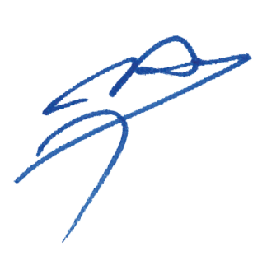
Yours sincerely,

Husnu KOCAOGLU
Chairman of the Organizing Committee

PRELIMINARY PROGRAM

24th of February 2019, Sunday Arrival of Delegations & Accreditation
Unofficial Practice

25th of February 2019, Monday Arrival of Delegations & Accreditation
Unofficial Practice

26th of February 2019, Tuesday Official Practice & Equipment Inspection
Team Manager’s Meeting

27th of February 2019, Wednesday Qualification Rounds

28th of February 2019, Thursday Individual Eliminations, 1/4 and 1/2 Finals
Junior Individual Eliminations, 1/4 and 1/2 Finals

01st March 2019, Friday Team Eliminations, Bronze & Gold Finals
Junior Team Eliminations, Bronze & Gold Finals
Teams Award Ceremony

02nd of March 2019, Saturday Junior Individual Bronze & Gold Finals
Junior Award Ceremony
Individual Bronze & Gold Finals
Individual Award Ceremony

03rd of March 2019, Sunday Departure of Teams

Note
This preliminary programme could change according to the number of participants and TV requirements. All changes to the programme will be published and informed to all participants in good time.

PRELIMINARY & FINAL REGISTRATION

No entry forms will be available to register for this event; the registration process must be completed using WAREOS.

Member Associations can login WAREOS at http://register.worldarchery.org with the username and password assigned by World Archery. After entering WAREOS, selecting the event from list will allow a member association to register their athletes. Select/press “Entries” button to see list of categories in the event. Select/press the “Category” to enter the athlete and official numbers/details participating for that event.

For any questions regarding the WAREOS, please contact the World Archery office, Mr. JK LEE (jklee@archery.org).

A maximum number of three (3) athletes per country can be registered into each category and divisions of the event.

- Starting date of on-line registration with WAREOS : 26th of October 2018
- End of Preliminary Registration using WAREOS : 30th of December 2018
- End of Final Registration using WAREOS : 06th of February 2019

Please respect the stated deadlines.

Member Associations should only use WAREOS to make any changes/amendments to their entries and will be able to do so at any time. Any changes made in WAREOS an email will be automatically sent to the Organizing Committee and Member Association with the updated information.

However, any changes that are made after the deadlines specified or if entries differ by more than 4 athletes from the preliminary entries, the following penalty fees will automatically be applied:

Penalty fees to be paid to Organising Committee: | Cost (EURO):
Entries made after the preliminary and/or final entry deadline date. | 45 per entry
If final entries differ from the preliminary entries by more than 6 athletes/officials. | 140 per entry
Failure to have made preliminary entries before the deadline date but then have submitted final entries. | 140 per entry

Any entries received less than 3 days before the team managers meeting will be refused if no preliminary entry and/or final entry are made prior.

As a final note, only Member Associations in good standing will be eligible to compete. This means that World Archery fee must have been paid prior the participation.

ACCOMMODATION AND TRANSPORTATION

Official Hotels are SHERATON HOTEL, SERRA HOTEL and ANEMON HOTEL in Samsun.
Hotel rates include “full board” (breakfast, lunch and dinner including beverages). In addition, tea, coffee and 0,5-liter water are available from 10:00 to 22:00 hrs. at the hotels.

Room rates specified is per person per night, which includes service charge and VAT.

Transportation from/to Samsun Carsamba Airport is 50 € per person for all participants. A daily shuttle service is free of charge (only for persons accommodated at official hotels). Shuttle services will be available from/to official hotels – competition venue.

Hotel and Transportation reservation should be made before 26 December 2018. Booking will only be valid once a 50% deposit has been received by the LOC before 26 December 2018. Full payments are to be made before 06 February 2019.

Reservation after this date shall be subject to availability.

HOTEL | CATEGORY | SINGLE ROOM | DOUBLE ROOM (PER PERSON)
SHERATON HOTEL | 5* | 160,00 € | 120,00 €
SERRA HOTEL | 5* | 130,00 € | 95,00 €
ANEMON HOTEL | 5* | 135,00 € | 100,00 €
NORTH POINT HOTEL | 4* | 84,00 € | 60,00 €

The Teams who do not reserve their accommodation

ENTRY FEES

- Individual Entry Fee : 150,00 € per Archer
- Team Entry Fee : 75,00 € per Team
- Officials Entry Fee : 50,00 € per Official

NON – OFFICIAL HOTELS

Participants who book their accommodation in non-official hotels will have to pay double entry fee, and the LOC is not responsible to provide any transportation meals from NON -Official Hotels. In addition, no information will be distributed to the nonofficial hotels.
Furthermore, they have the register at accreditation no later than the day before the official practice. If they do not register the day before, no changes will be made to the entry list and it is likely that they will not be able allowed to compete.

HOTELS

Room rates for all hotels are per person per night and include, Breakfast, Lunch and Dinner. There will be free internet access at the official hotel’s in at the lobby and rooms.
SHERATON HOTEL*****

Sheraton Hotel located 800m, 2 minutes (driving), 10 minutes walking distance to competition venue.
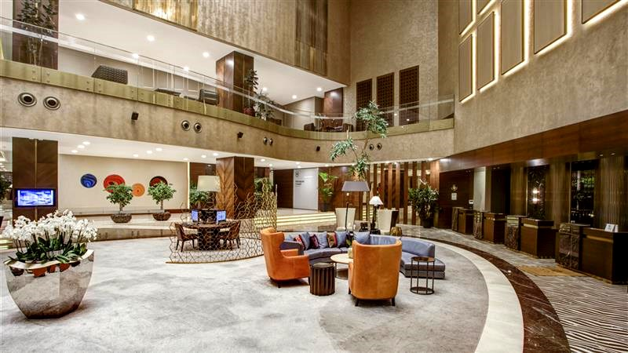

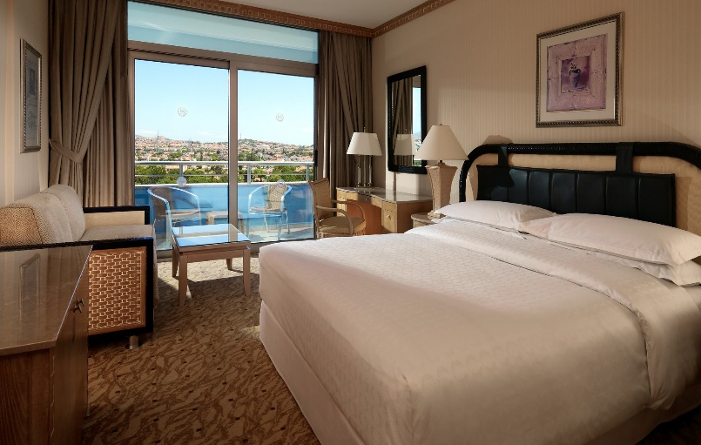
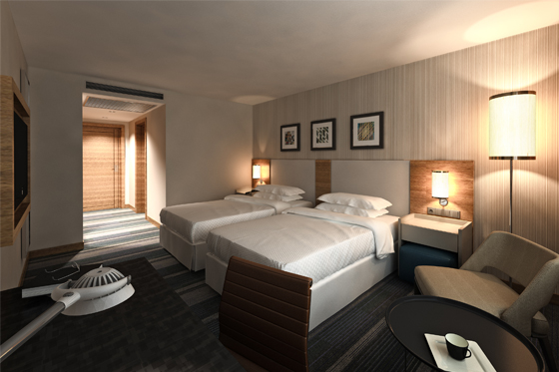

RATES PER PERSON PER NIGHT
Single Room | 160,00 €
Twin/Double Room | 120,00 €

SERRA HOTEL *****

Serra Hotel located 2,1 km, 5 minutes (driving) and 20 minutes walking distance to competition venue.

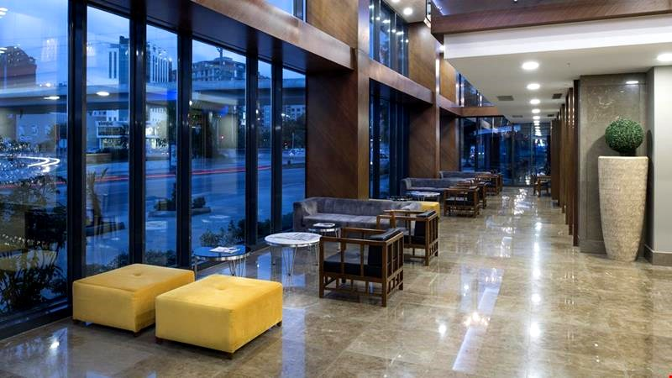
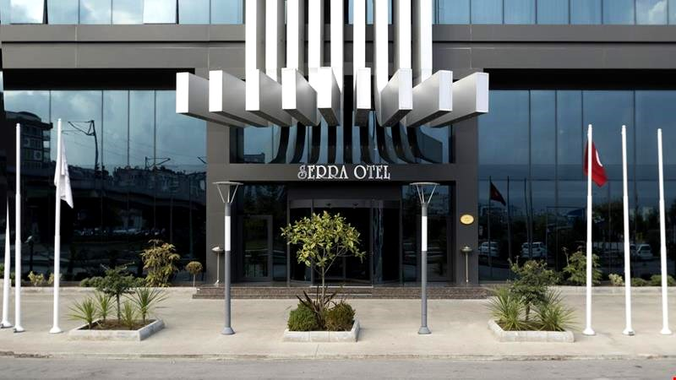

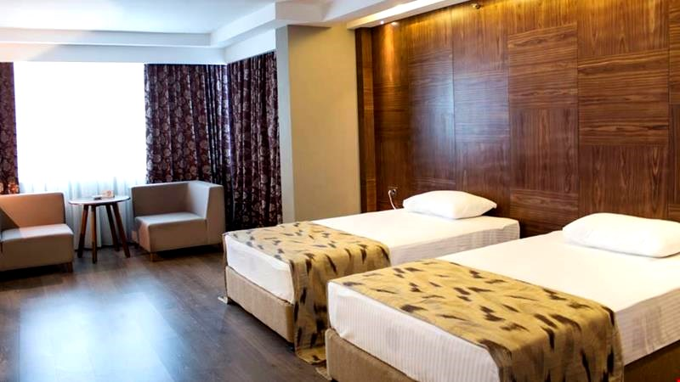
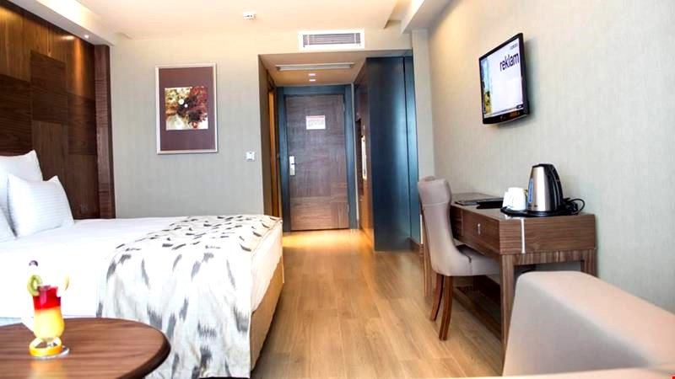

RATES PER PERSON PER NIGHT
Single Room | 130,00 €
Twin/Double Room | 95,00 €

ANEMON HOTEL *****

Anemon Hotel 6,8 km, 12 minutes (driving) distance to competition venue.
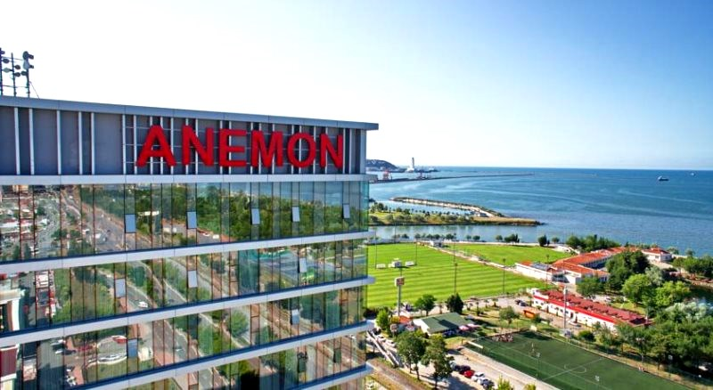
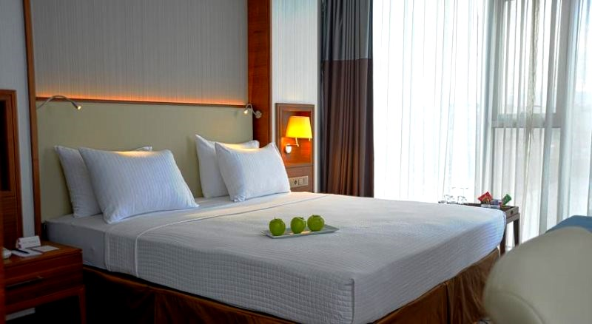

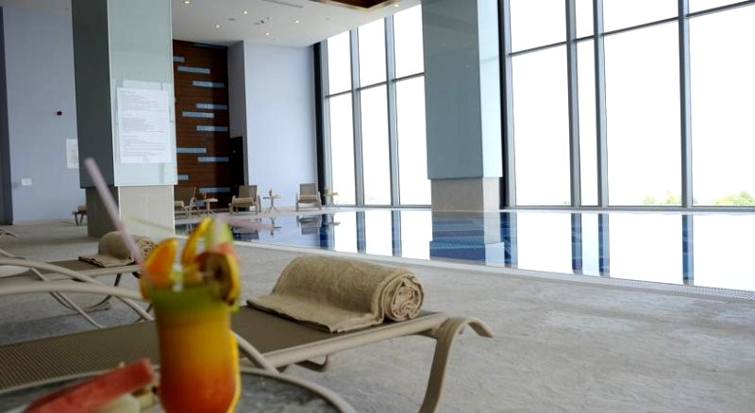
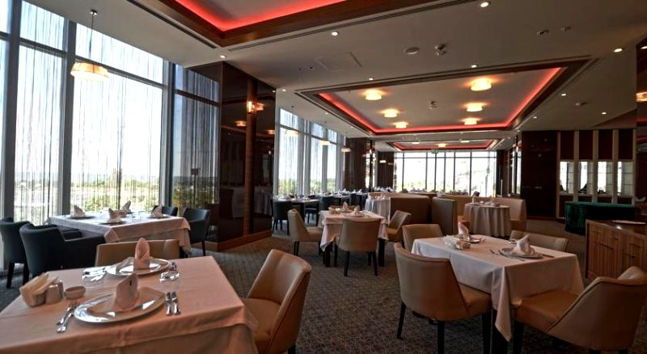

RATES PER PERSON PER NIGHT
Single Room | 135,00 €
Twin/Double Room | 100,00 €

NORTH POINT HOTEL ****

North Point Hotel 3,8 km, 6 minutes (driving) distance to competition venue.
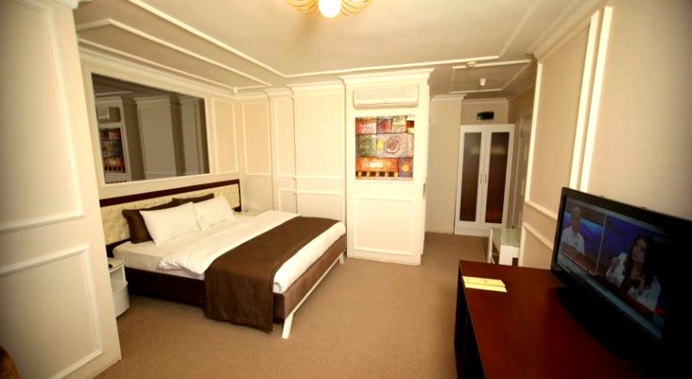
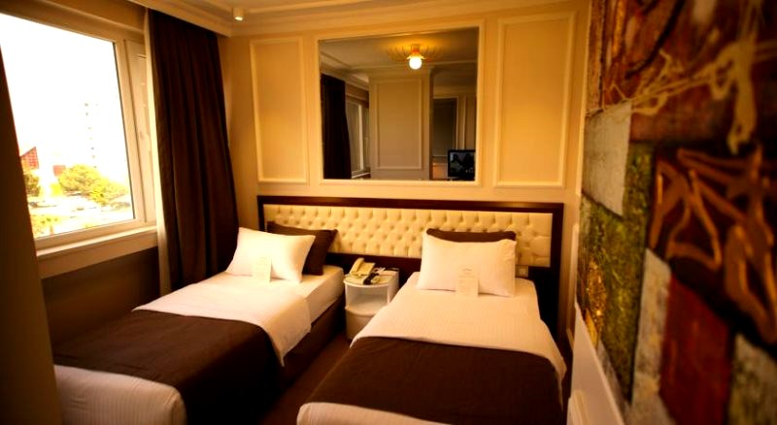
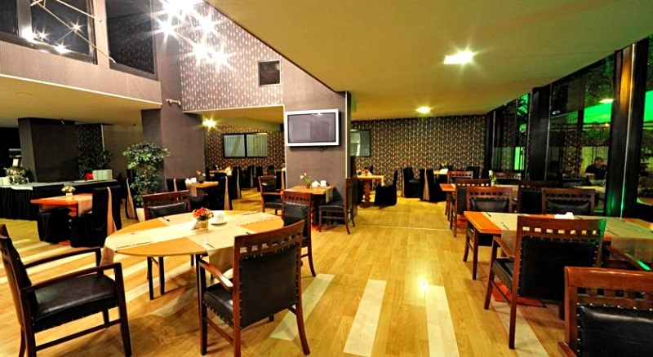
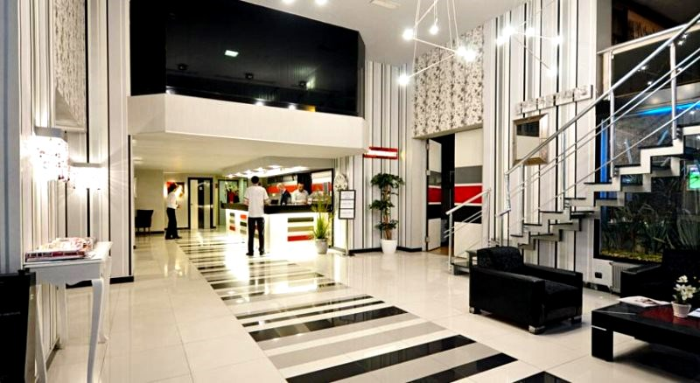

RATES PER PERSON PER NIGHT
Single Room | 84,00 €
Twin/Double Room | 60,00 €

CANCELLATIONS & CHANGES

Cancellation must be made by email to info@antalyaokculuk.org and be received before 26 December 2018 for a complete refund of deposit paid. Refunds will be processed after the event.

Any entries received after this date will not be eligible for refund. All rates for payment after deadlines are subject to additional changes without prior notice.

PAYMENT INSTRUCTION

All payments are to be made in Euros by bank transfer to:

Payment for Bank Transfer

Account Name : ANTALYA OKCULUK IHTISAS SPOR KULUBU
Bank : YAPI KREDI BANKASI
Account Number : 25086669
Swift Code : YAPITRIS

IBAN : TR 03 0006 7010 0000 0025 0866 69

We regret that credit cards and travelers’ cheques will not be accepted.

Bank transfer fee are the responsibility of the sender.

Entry and accommodation fees must be paid in full before arrival.

VISA SUPPORT

All participants who need an entry visa to Turkey, will be required to complete the Visa Support Form in WAREOS by no later than 26 December 2018.

It is the applicants’ responsibility for supplying necessary information, ensuring all details are up to date, correct and submitted by the deadlines specified.

In addition, all participants that require a visa are kindly requested to supply a copy of their latest/valid passport. Copies of each applicate can be uploaded on WAREOS. All passport copies and personal details entered/uploaded to WAREOS will be held securely and in the strictest of confidence and shared with other parties.

Please note that the Organizing Committee can provide invitation for the period of the 2019 European Indoor Archery Championship.

LOC Contact:

Name : Sirer AYDIN

Email : sireraydin@gmail.com

ARCHERY VENUE

The Qualification, Eliminations and Finals will be held at the Samsun Ilkadım Okculuk Tesisleri, Atatürk Bulvarı, Baruthane Mahallesi, 55100 Ilkadim, Samsun - TURKEY

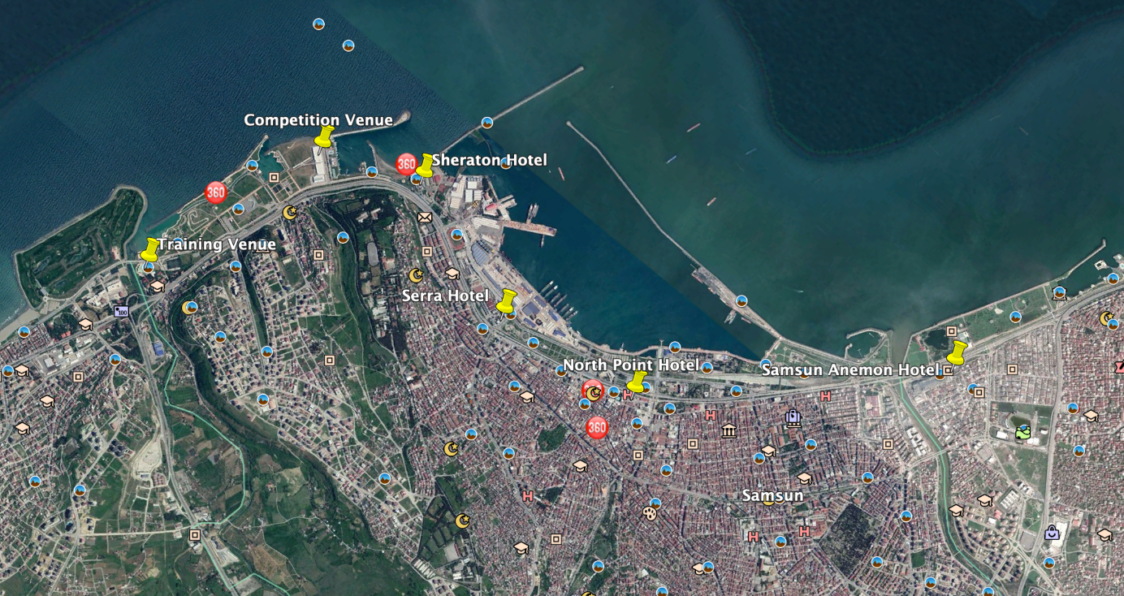

TRAINING

A training field will be available starting from 24 February 2019. The training field is walking distance to the competition field. Transportation between the official hotels and venues will be provided.

WATER ON THE VENUE

Bottled water will be provided on venue during the competition for accredited persons.

WHETHER IN SAMSUN

February (Average) :
Average Temperature : 07^{O} C
Low Temperature : 04^{O} C
High Temperature : 10,6^{O} C
Sunshine Hours : 3,2 Hrs.
Rainfall Days : 13,5 days

